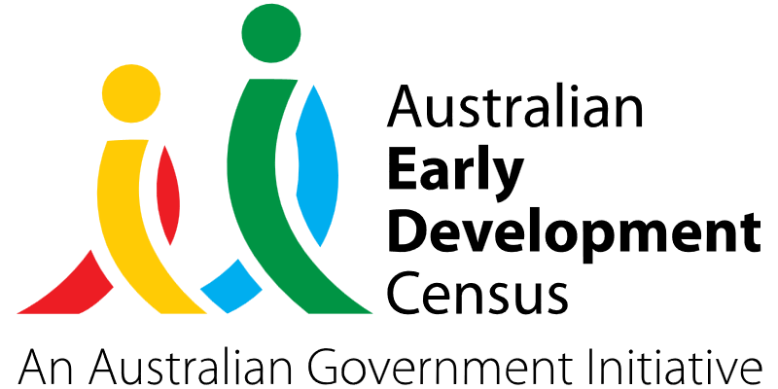
Physical Health/Wellbeing Prosocial Play Program

Ambrose Early Learning St John XXIII

About the community
Stanhope Gardens is a suburb of Greater Western Sydney in NSW, located 31 kilometres north-west of the Sydney central business district in the local government area of City of Blacktown.
The Catholic learning community of St John XXII Parish is comprised of St John XXIII Catholic Primary School (K–6) and St John XXIII Catholic College (K–12), Ambrose Outside of School Care, and the Catholic Early Learning Centre, all situated on the grounds of the College.
There are over 80 families who are enrolled at the early childhood education and care service, which includes children from 30 different cultural backgrounds. When they start school, a large percentage of these children will attend the parish school.

What did the data show?
The Australian Early Development Census (AEDC) is a national measure of early childhood development that is collected at the time children commence their first year of full-time schooling. The AEDC collects data relating to 5 key areas of early childhood development referred to as ‘domains’. The domains are physical health and wellbeing, social competence, emotional maturity, language and cognitive skills (school-based), communication skills and general knowledge.
The 2021 AEDC data for Stanhope Gardens showed an increase in the proportion of children assessed as developmentally vulnerable in the physical health and
wellbeing domain (from 6.5% in 2018 to 10.6% in 2021), social competence domain (from 8.9% in 2018 to 12.5% in 2021) and communication skills and general knowledge domain (from 4.9% in 2018 to 9.6% in 2021).

Bringing about change
The Physical Health/Wellbeing Prosocial Play Program was developed to narrow the gap between developmentally vulnerable children and those ‘on track’ in 3 of the AEDC domains. These domains are physical health and wellbeing, social competence and communication skills and general knowledge. The following community initiatives were implemented:
- purchase of an interactive whiteboard to be used in multiple play spaces and in Kindergarten classes to encourage literacy, numeracy, social and communication skills through increased engagement during group times
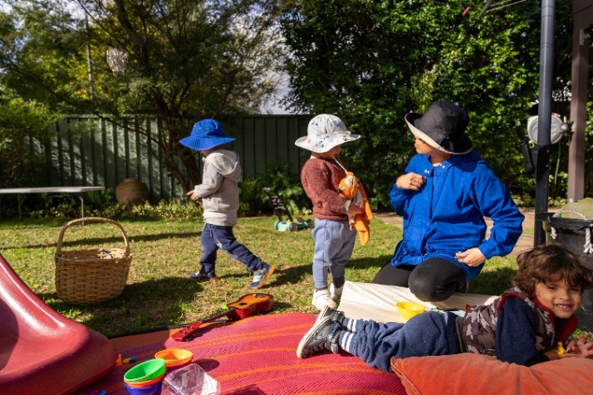
- Healthy Harold life education visits to promote physical health and social and emotional wellbeing in children, with resources and activities provided to continue learning beyond the visit
- participation of educators in the ‘Bigger Better Brains’ music education program. The program recognises music as a powerful tool for different neurological developments including working memory, cognitive flexibility, impulse control, language acquisition and attention
- purchase of yoga resources and releasing educators to attend a yoga workshop focusing on encouraging yoga, mindfulness, breathing techniques and resilience to share with students at the Catholic Early Learning Centre.
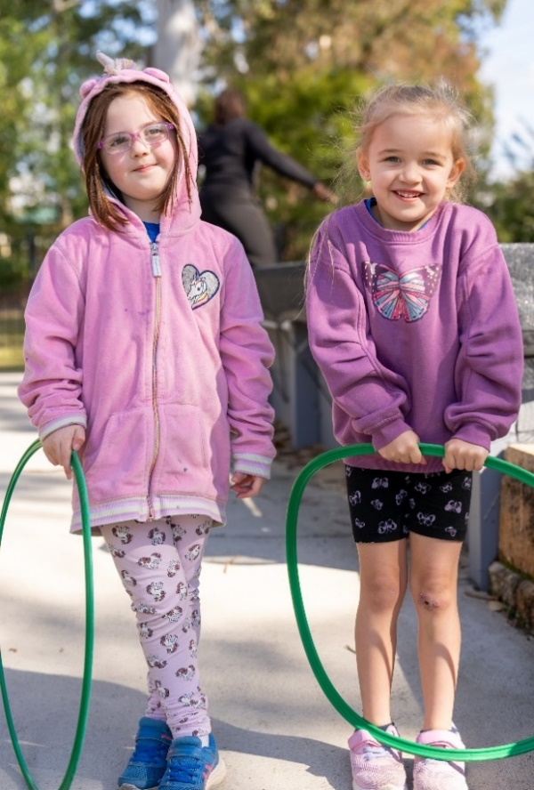

Partnerships
To deliver the Physical Health/Wellbeing Prosocial Play Program, the Catholic Early Learning Centre partnered with various community members, including:
- School community – St John XXIII Catholic Community Stanhope Gardens
- Parish community – St John XXII Parish
- Ambrose Early Learning Services.

Achievements
The Physical Health/Wellbeing Prosocial Play Program has led to the increased participation of students in physical play-based experiences and language-based experiences. Children have demonstrated an increased interest in physical activities including yoga, games with rules, and fundamental movement skills. The children have enthusiastically discussed healthy lifestyle practices that were learned during excursions and have continued building their skills and knowledge at home by interacting with the Healthy Harold program resources that were provided to families.
Through the ‘Bigger Better Brains’ music education program, educators were able to reflect on how music learning positively affects language development and have intentionally implemented beat-keeping and music in their learning programs to support children with additional needs.

Looking ahead
The Catholic Early Learning Centre St John XXII Parish would like to provide training to educators to effectively use the interactive whiteboard to support children’s increased engagement in group learning experiences, as well as continue to build on yoga and mindfulness skills and practices.
For more information, contact the AEDC NSW Project Team:
Phone: 1300 083 698
Email: aedc@det.nsw.edu.au

