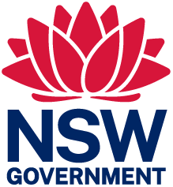 | 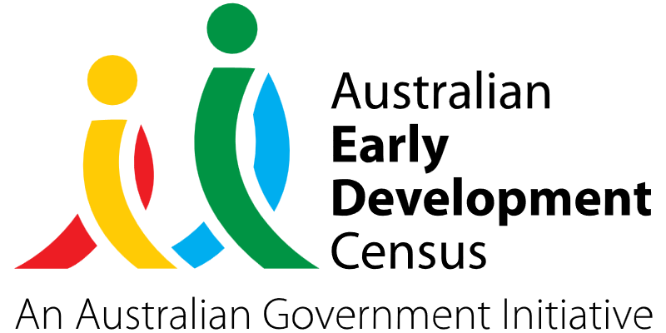
Community hub

Branxton Preschool

About the community
Branxton is a town in the Hunter Region of New South Wales, located in the Cessnock local government area approximately 171 kilometres north of Sydney.
Branxton Preschool is a not-for-profit, community-based preschool providing education and care for 50 children a day aged between 3 to 6 years.

What did the data show?
The Australian Early Development Census (AEDC) is a national measure of early childhood development that is collected at the time children commence their first year of full-time schooling. The AEDC collects data relating to 5 key areas of early childhood development referred to as ‘domains’. The domains are physical health and wellbeing, social competence, emotional maturity, language and cognitive skills (school-based), communication skills and general knowledge.
The 2021 AEDC data outcomes for the Cessnock community showed significant increases in the percentage of children vulnerable in one or more domains (from 22.8% in 2018 to 28.5% in 2021) and the percentage of children vulnerable in 2 or more domains (from 11.3% in 2018 to 16.8% in 2021).
There were also significant increases in the percentage of children developmentally vulnerable across 4 out of 5 of the domains: physical health and wellbeing (from 10.3% in 2018 to 15.2% in 2021), social competence (from 10.9% in 2018 to 16.1% in 2021), emotional maturity (from 7.7% in 2018 to 10.9% in 2021), and communication skills and general knowledge (from 7.2% in 2018 to 10.5% in 2021).

Bringing about change
Within the Cessnock local community, access to allied health services is extremely limited. Staff and parents have noted an increase in waiting periods to access speech pathology, occupational therapy, and other support agency services.
Branxton Preschool developed the Community Hub project to support the growing needs of children within the local community and provide them with the best opportunities to realise their full potential prior to school. The aim of the project was to offer access to speech and occupational therapy sessions, and to build the capacity of staff and families to support children with their developmental needs.
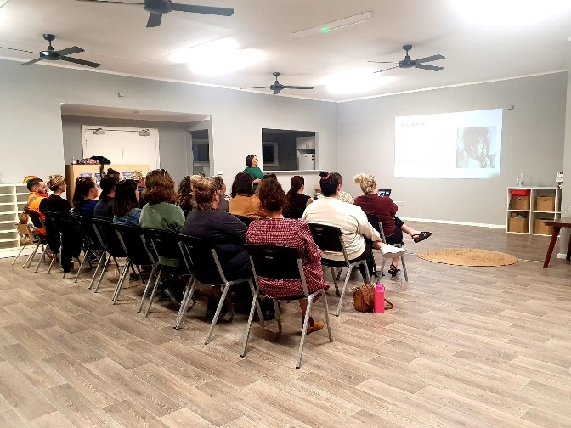
The advantage of a community hub functioning within the Branxton Preschool service was not only to support the child and educational team, but to also provide a space for families to connect with each other and to grow their parenting skills and knowledge in a supportive environment.
A psychologist was brought into the service to hold workshops for parents on building a child’s emotional resilience and for educators on raising concerns with families as this can be quite a challenging topic for newer educators to the sector.
Gymbaroo teachers were also brought into the preschool to conduct assessments for retained primitive reflexes in children and to assist and guide staff to support and work with children to help improve their physical, emotional and overall wellbeing.
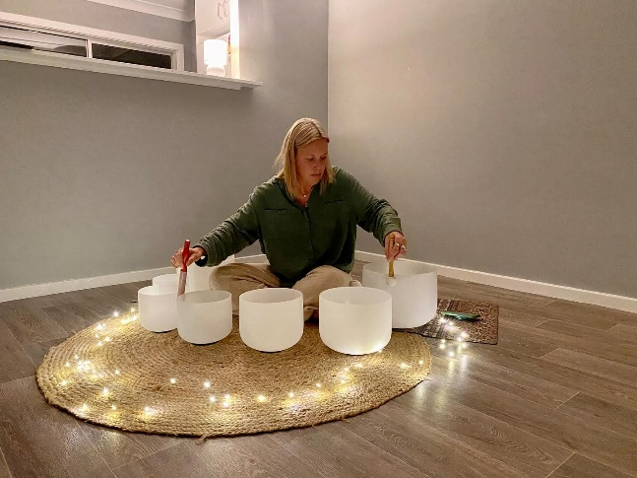

Partnerships
To deliver the Community Hub project, Branxton Preschool partnered with Andrea Cooper Speech Pathology, Marina Bailey Psychological Services, Nature & Nurture and Your Yoga Spot. These providers had previously attended the preschool for private NDIS funded sessions with some of the children, so were able to build on existing relationships with students and staff.

Achievements
As a result of the Community Hub project, Branxton Preschool has seen a large increase in the number of families accessing speech therapists, with all children flagged as needing additional support being able to access the speech screening opportunity offered by the preschool.
Educators reported seeing remarkable improvements in the social skills and language development of children as evidenced by connectedness to peers, friendship groupings, improved communication, social behaviours, and achievement of learning outcomes.
The project increased the confidence and knowledge of the Branxton Preschool staff to develop and implement individual programs supporting children’s developmental needs. Educators were able to restructure their learning environments and teaching strategies to ensure children had the best opportunity to engage in social, language, and physical skill development.
The needs and wellbeing of parents were supported by the Community Hub project, and they were empowered to work as a family unit to support their child’s needs. Running workshops and courses at the preschool that families would otherwise have had to travel to attend helped to remove barriers for parents to access community support.
Families were upskilled and educated on the importance of social behaviours and how to guide children with emotional resilience. Many families not only accessed the parent workshops but have since been in contact directly with the psychologist to gain further support on how to best equip their child with required life skills leading into school.

Looking ahead
Branxton Preschool plans to continue working in partnership with allied health services in the future to increase family engagement and capacity. The community hub space at Branxton Preschool now offers Gymbaroo, sensory art classes, yoga for children and adults as well as parent workshops. All of this contributes to the goal of Branxton Preschool to assist families, children and the wider community with access to services and opportunities to learn new skills to improve developmental outcomes for children.
For more information, contact the AEDC NSW Project Team:
Phone: 1300 083 698
Email: aedc@det.nsw.edu.au

