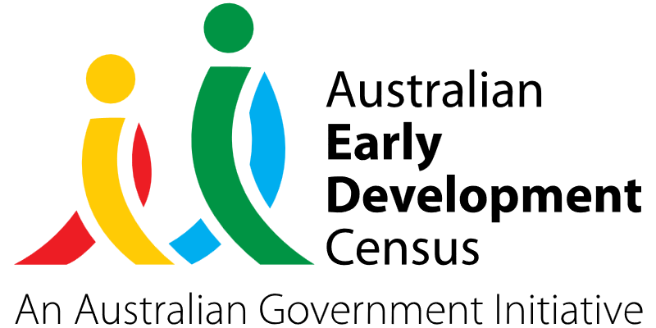
Staff capacity development

Cawdor Public School

About the community
Located in a semi-rural setting close to Camden NSW, Cawdor Public School is a small school with a total current enrolment of 79 students. The school has 7 Aboriginal and Torres Strait Islander students, as well as an increasing number of students enrolling with additional needs.

What did the data show?
The Australian Early Development Census (AEDC) is a national measure of early childhood development that is collected at the time children commence their first year of full-time schooling. The AEDC collects data relating to 5 key areas of early childhood development referred to as ‘domains’. The domains are physical health and wellbeing, social competence, emotional maturity, language and cognitive skills (school-based), communication skills and general knowledge.
The 2021 AEDC data for Cawdor Public School showed a significant decline in the proportion of children assessed as developmentally on track in the language and cognitive skills (school-based) domain, from 100% in 2018 to 75% in 2021.

Bringing about change
The ‘staff capacity development’ project was designed to improve the oral language and literacy skills of K–2 students by upskilling staff to improve their support of early phonics, phonemic awareness and reading fluency.
A strategy to achieve this included building take-home literacy resource packs to support students’ learning at home. The project directly addressed the language and cognitive skills (school-based) domain that was highlighted as a key area of need in Cawdor Public School’s 2021 AEDC data.
Through the project, educators undertook InitiaLit professional learning through the MultiLit Literacy Centre, which is an evidence-based whole-class literacy program. One teacher and one School Learning Support Officer (SLSO) also took part in the MiniLit Sage program, a Tier 2 small group reading program specifically aimed at Year 1 and 2 students requiring intensive support to develop decoding skills. The program provided explicit instruction in phonemic awareness, systematic synthetic phonics for reading and spelling, letter formation, and connected text reading that educators could apply with students in classrooms.
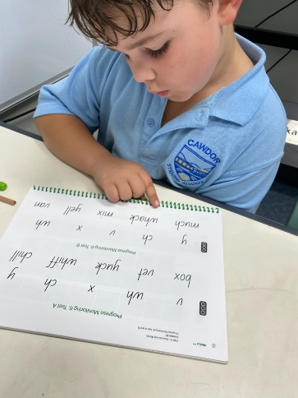
Cawdor Public School also committed to purchasing the resources and decodable readers from the program for classroom use, and parent workshops were delivered at the school to increase their understanding of foundational literacy skills to support children at home.

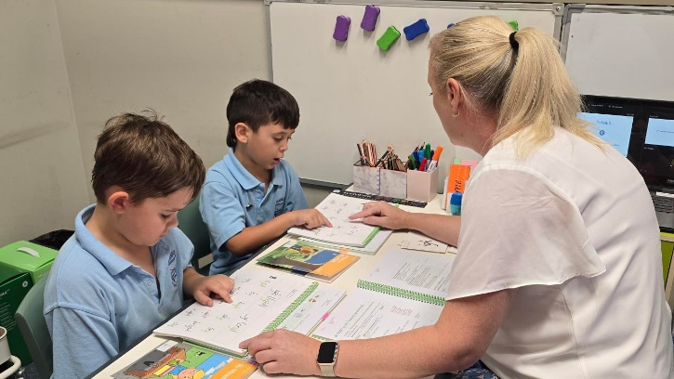

Partnerships
Cawdor Public School collaborated with parents and carers who developed the resource packs. The MultiLit Literacy Centre Sydney delivered the MiniLit Sage and InitiaLit-Foundation professional learning to staff.

Achievements
The ‘staff capacity development’ project had a significant impact on both student achievement and the professional growth of staff involved. It enhanced student performance and established valuable teaching and learning environments that were particularly beneficial for students encountering challenges in reading.
Staff experienced a notable increase in their confidence as educators and an expansion of pedagogical expertise, fostering a deep knowledge of student strengths and learning needs. The use of small groups facilitated close interaction between staff and students, enabling immediate identification and resolution of difficulties or misconceptions encountered by learners. Educators reported feeling heightened job satisfaction and feeling more empowered and capable in their roles as a direct result of the professional learning opportunities, comprehensive program support and observable student progress.
Student progress was measured through initial baseline assessments to gauge proficiency levels before program implementation and follow-up assessments post implementation. These measured the progress and efficiency of the MiniLit Sage program. Results showed 100% of targeted students exhibited a notable advancement in their reading abilities, with each student demonstrating a minimum improvement of 20%. Notably, 2 students recorded more than a 500% improvement in their initial reading scores. 92% of targeted students demonstrated improvements in their decoding abilities as observed through non-word reading fluency assessments, with 5 students showcasing remarkable enhancements surpassing 100%.
Many students also displayed a strong enthusiasm for extending their learning beyond the classroom, fostering positive collaborations and partnerships between the school and families. Parents became partners in student learning by working on the same in-class MiniLit activities at home with their children, using the provided take home pack of resources. Letters were sent home outlining the program and staff regularly updated parents on their child’s progress and what to focus on to help their child improve.

Looking ahead
Going forward, Cawdor Public School would like to train more staff in the evidence-based literacy programs and fully implement the InitiaLit program with Kindergarten students. Parent workshops will be held in 2024 to enhance and strengthen the links between home and school in literacy programs.
For more information, contact the AEDC NSW Project Team:
Phone: 1300 083 698
Email: aedc@det.nsw.edu.au

