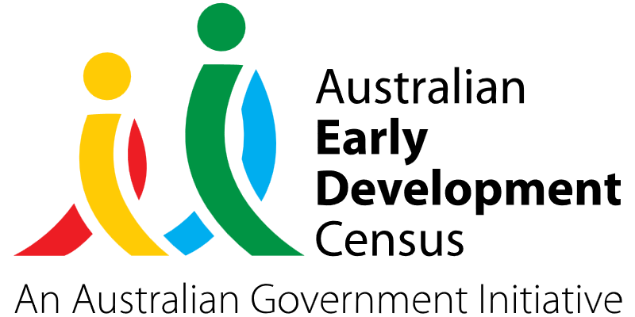
Engine Room Educator Capacity Building Program

Coolah Preschool Kindergarten Inc.

About the community
Coolah is a town in central western NSW, in the Warrumbungle Shire region. It is located approximately 376 kilometres north-west of Sydney and 109 kilometres north of Mudgee.
There are currently 41 children enrolled at Coolah Preschool Kindergarten Inc (CPKi), several of whom have high learning support needs. CPKi has recently completed the construction of a purpose-built sensory space (the ‘Engine Room’) to meet the increasing developmental needs of preschoolers within the Coolah community.

What did the data show?
The Australian Early Development Census (AEDC) is a national measure of early childhood development that is collected at the time children commence their first year of full-time schooling. The AEDC collects data relating to 5 key areas of early childhood development referred to as ‘domains’. The domains are physical health and wellbeing, social competence, emotional maturity, language and cognitive skills (school-based), communication skills and general knowledge.
The 2021 AEDC outcomes for the Warrumbungle community showed higher rates of developmental vulnerabilities across all 5 domains compared to NSW and Australia averages, as summarised in the table below.

Developmentally vulnerable in 2021 | Warrumbungle | NSW | Australia
Physical | 16.5% | 9.4% | 9.8%
Social | 10.3% | 9.4% | 9.6%
Emotional | 10.3% | 7.3% | 8.5%
Language | 10.3% | 6.2% | 7.3%
Communication | 10.3% | 8.4% | 8.4%

Bringing about change
The Engine Room Educator Capacity Building Program (ERECBP) is a hands-on training and development partnership program conducted by qualified speech and occupational therapists. Focusing on the social competence and emotional maturity domains, the program targeted speech and communication skills and self-regulation.
The program was developed to build the knowledge, skills and capacity of CPKi educators to identify the developmental needs of preschool children and to use the equipment and resources in the Engine Room to build programs addressing these needs.
As part of the program, educators undertook Movement and Learning workshops with Brendan O’Hara who is a kinesiologist, education consultant and musician.
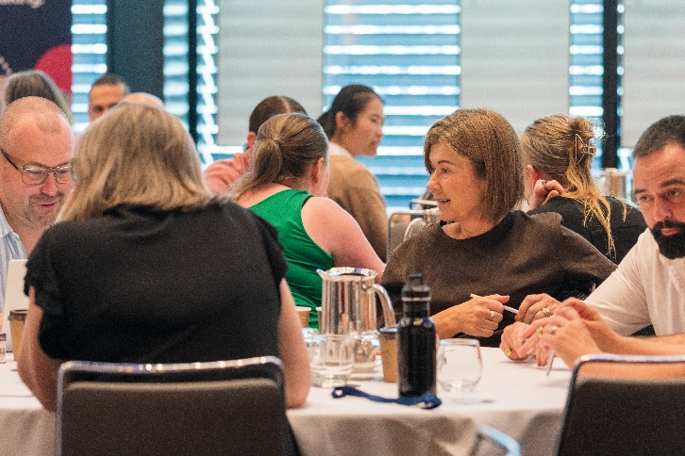
Blending child-friendly music with fun movement activities creates and strengthens neural networks in the brain to increase concentration and focus, self-esteem, coordination and balance, visual and spatial awareness, calm behaviour and self-regulation, and enhances transition to school.
Educators also attended the University of Wollongong Early Start Denver Model workshop which follows a play-based approach to support language, social and cognitive skills development for children with autism or similar developmental needs. The model is underpinned by play-based learning, developing secure and reciprocal relationships, promoting all forms of communication, and following children interests and choices.
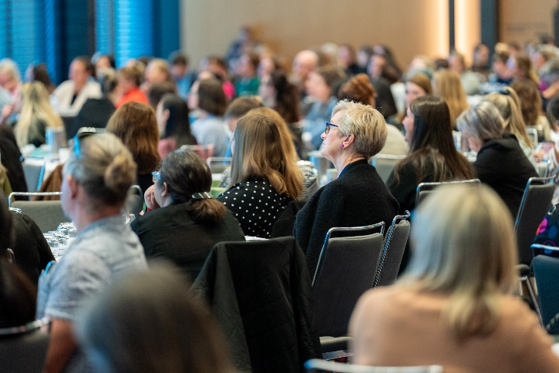

Partnerships
The Engine Room Educator Capacity Building Program involved partnerships with CPKi families, experienced and qualified speech and occupational therapists including Sarah Yeates (occupational therapist), Meg Sheridan (speech therapist) and Mardi Taylor (occupational therapist), and Orana Early Childhood Intervention who provided developmental screening services to students.

Looking ahead
An area of focus for CPKi in the future will be on removing the stigma around accessing therapy for children with additional needs. During the program implementation, educators met challenges around engagement with assessments and therapy recommendations.
For more information, contact the AEDC NSW Project Team:
Phone: 1300 083 698
Email: aedc@det.nsw.edu.au

