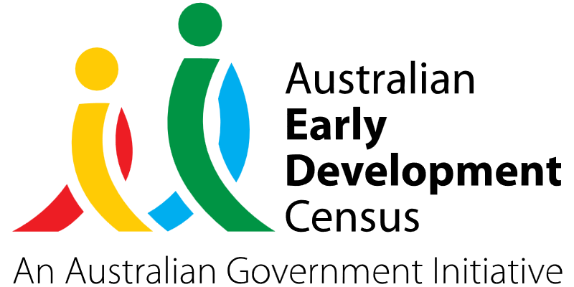
Music Therapy

Little Angels at Pagewood Green

About the community
Located in the Eastern Suburbs of Sydney, the suburb of Eastgardens sits 9 kilometres south-east of the Sydney central business district in the Bayside Council. It is surrounded by the suburbs of Pagewood, Maroubra, Hillsdale and Banksmeadow.
Little Angels at Pagewood Green is based in Eastgardens and provides early childhood education and care services for children aged between 6 weeks and 6 years, through various inclusive and personalised long day care programs tailored to each child’s individual development.

What did the data show?
The Australian Early Development Census (AEDC) is a national measure of early childhood development that is collected at the time children commence their first year of full-time schooling. The AEDC collects data relating to 5 key areas of early childhood development referred to as ‘domains’. The domains are physical health and wellbeing, social competence, emotional maturity, language and cognitive skills (school-based), communication skills and general knowledge.
The 2021 AEDC outcomes for the Pagewood/Daceyville/Eastgardens local community showed an increase in developmental vulnerabilities – 20.3% were vulnerable in one or more domains (compared to 14.8% in 2018) and 9.9% were vulnerable in 2 or more domains (compared to 5.5% in 2018).

Bringing about change
The music therapy program was developed by Little Angels at Pagewood Green to support children enrolled in the service across all 5 AEDC domains, with a particular focus on language and cognitive skills.
This was driven by educator observations which indicated that an increasing number of children were attending the service with speech and communication delays. Educators believed that the impact of COVID restrictions, such as mask wearing and limited exposure to the wider community, has influenced the speech and language development of children attending the service.
Incorporating music therapy within the curriculum at Little Angels at Pagewood Green catered to the diverse psychosocial needs of children through songwriting, improvisation and providing opportunities for self-expression and communication.
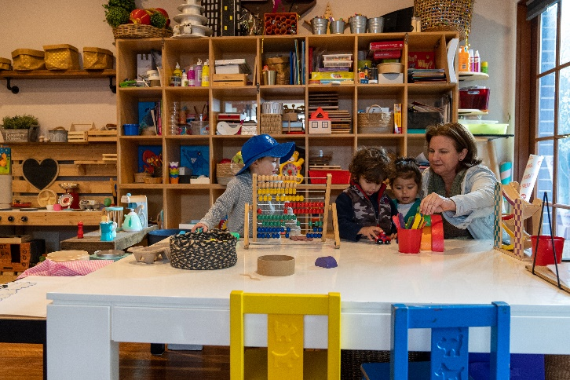
The music therapy sessions were used to promote early language development including sounds, words and sentences, improve memory, promote play skills such as turn-taking, sharing, listening and following instructions, and build children’s self-esteem and confidence.
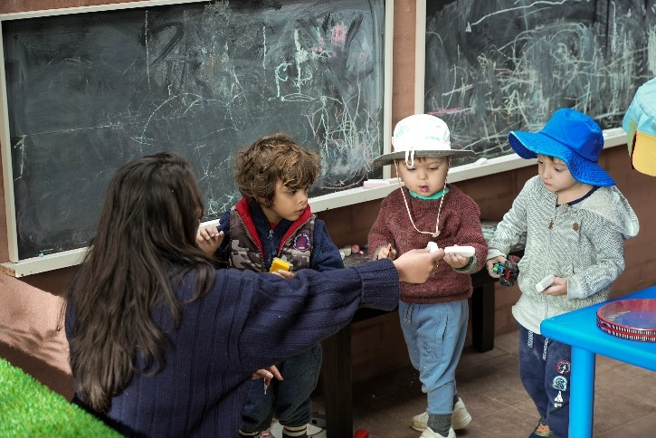

Partnerships
Little Angels at Pagewood Green partnered with local dual therapist June Boon from Kita Speech and Music Therapy to deliver the music therapy sessions. The program also involved participation from children, parents, educators and management.

Achievements
All the children at the service benefited greatly from the music therapy program, which was supported by the regular reflections and positive feedback received from educators, parents, and music therapists from Kita Speech and Music Therapy. The program effectively supported children's mental health and wellbeing, creative expression, speech and communication, as well as their physical, cognitive, social and sensory processing skills.

Looking ahead
Little Angels at Pagewood Green would like to establish broader links with the community in the future, particularly with the aged care community, through accessing an inter-generational program with a local facility. The service would also like to provide further support to educators to enable them to effectively respond to challenging behaviour.
For more information, contact the AEDC NSW Project Team:
Phone: 1300 083 698
Email: aedc@det.nsw.edu.au

