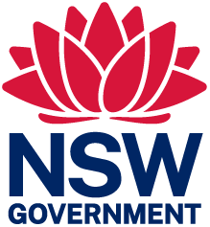 | 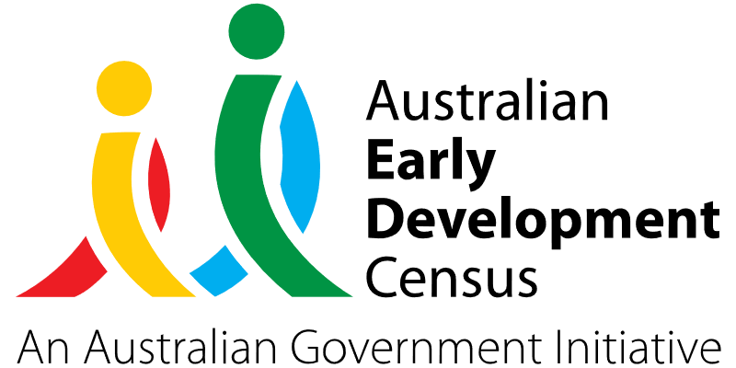
Building Blocks

Adamstown Public School

About the community
Adamstown Public School is a K-6 mainstream school situated in inner city Newcastle. The school has 15 classes and consists of a diverse community, with families from a range of social and multicultural backgrounds. Eight per cent of students at Adamstown Public School identify as Aboriginal or Torres Strait Islander and 12% of students have a language background other than English requiring English as an Additional Language or Dialect (EAL/D) support.

What did the data show?
The Australian Early Development Census (AEDC) is a national measure of early childhood development that is collected at the time children commence their first year of full-time school. The AEDC collects data relating to 5 key areas of early childhood development referred to as domains. The domains are: physical health and wellbeing; social competence; emotional maturity; language and cognitive skills (school-based); communication skills and general knowledge.
2021 AEDC data for Adamstown Public School has shown an increase in the percentage of children developmentally vulnerable on 2 or more domains, from 4.8% in 2018 to 7.9% in 2021. While there has been a significant increase in the percentage of children ‘on track’ in the physical health and communication skills and general knowledge domains from 2018 to 2021, there has been a slight decline in the percentage of children ‘on track’ in the social competence and emotional maturity domains during the same period.

Bringing about change
Evidence indicates that the early childhood years are fundamentally important for later development. As such, it is critical for all children and their families to have access to developmental activities, learning, exploration, and positive and inclusive relationships.
Educators at Adamstown Public School established the Building Blocks initiative to ensure that children have a strong start to school. The initiative is jointly constructed and run with local early childhood education services, community organisations and allied health professionals. It is open to all families in the community, with approximately 50 children attending each week, and aims to connect children and families with resources to help them feel safe and supported throughout their schooling life.

The sessions allow children to become familiar with the school environment and connect with their future classmates, in the presence of their parents or early learning educators. It implements a play-based curriculum that merges the Early Years Learning Framework (EYLF) and Early Stage 1 (ES1) curriculum, and supports the development of interpersonal qualities, independence, self-regulation, fine and gross motor skills, critical thinking, listening skills, and adapting to new routines. Each Building Blocks session includes a variety of activities and learning experiences such as music, stories, outdoor and indoor play, dramatic play, water play, arts and crafts, literacy and numeracy activities.

Under the initiative, teachers from Adamstown Public School also spent time in local preschools to team teach, make observations, and interact with children to build authentic relationships. This promotes students’ sense of belonging prior to starting Kindergarten and ensures children have a smooth transition to school.

Partnerships
The Building Blocks initiative was created and run with Adamstown Community Early Learning and Preschool, Rumpus Room Darling Street, Rumpus Room Chatham Street and Kinda Kapers Adamstown.
Partnerships were further established with:
- Awabakal Land Council
- Speech Pathologists
- Occupational Therapists
- Podiatrists
- Nutritionists
- Local Aboriginal Co-Operation
- Department of Education – Early Intervention
- Optometrists.

Achievements
The Building Blocks initiative has provided families access to positive learning experiences that they may not experience at home. It fosters a school environment that is equipped for the needs of all children before starting school through collaborative teamwork between parents, preschools, educators and external agencies sharing knowledge, skills and information.
Attendance data indicated that 4 local preschools and 20 local families engaged with Building Blocks every week. As a result of Building Blocks, kindergarten enrolments at Adamstown Public School have increased from 2 classes to 4 classes, driven by increased community confidence that the school fosters a culture of learning, success, growth and care.
A preschool survey conducted showed that 100% of early years educators valued the Building Blocks initiative and could identify how the program supported children to meet the AEDC domains. Feedback from parents and carers indicated that Building Blocks helped their child feel safe and ready for kindergarten.

Looking ahead
The long-term outcome for Building Blocks is to ensure that every child will commence Kindergarten with the foundations required for school success. They will have a strong sense of belonging, have secure and reciprocal relationships with educators to be successful learners, be confident and creative, and be active and informed citizens.
This will be supported by having more preschools in zone joining the program, as well as extending Building Blocks to include outside agencies such as speech pathologists, occupational therapists, podiatrists, and local land councils to better support the learning, development and wellbeing of children.
Going forward, Building Blocks will also focus on building more community awareness and understanding of what is available within the school, and create stronger connections with preschools zoned for Adamstown Public School by having them attend school events such as assemblies to increase familiarity with the environment and to gain knowledge of how educators role model for the students.
For more information, contact the AEDC NSW Project Team:
Phone: 1300 083 698
Email: aedc@det.nsw.edu.au

