Resilience Project at BPS

Berkeley Public School

About the community
Berkeley is a suburb of Wollongong, New South Wales, located on the northern shore of Lake Illawarra.
Berkeley Public School (BPS) is a K-6 primary school with an enrolment of 289 students in 2022. The school has 12 classes and draws from a variety of diverse demographics. 23% of students in the school have a language background other than English with Macedonian being the most prevalent, and 21% of students identify as Aboriginal or Torres Strait Islander.
The Index of Community Socio-Educational Advantage (ICSEA) value for Berkeley Public School was 923 in 2022 which placed the school in the 16th percentile, indicating that Berkeley Public School is more educationally disadvantaged than 84% of schools in Australia.

What did the data show?
The Australian Early Development Census (AEDC) is a national measure of early childhood development that is collected at the time children commence their first year of full-time school. The AEDC collects data relating to 5 key areas of early childhood development referred to as domains. The domains are: physical health and wellbeing; social competence; emotional maturity; language and cognitive skills (school-based); communication skills and general knowledge.
The 2021 AEDC data outcomes for Berkeley Public School showed significant increases in the percentage of children vulnerable on one or more domain(s) (from 20.0% in 2018 to 46.9% in 2021) and the percentage of children vulnerable on 2 or more domains (from 8.0% in 2018 to 25.0% in 2021).
There were also significant declines in the percentage of children developmentally on track across 4 out of 5 of the domains: physical health and wellbeing (from 76.0% in 2018 to 28.1% in 2021), social competence (from 74.0% in 2018 to 34.4% in 2021), emotional maturity (from 82.0% in 2018 to 59.4% in 2021), and communication skills and general knowledge (from 72.0% in 2018 to 34.4% in 2021).
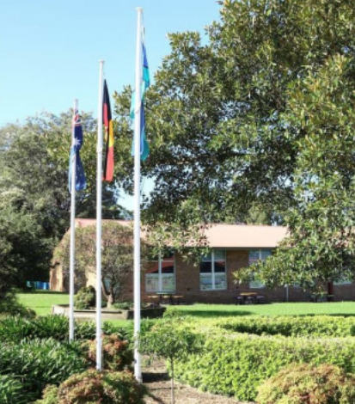

Bringing about change
The Resilience Project at Berkeley Public School (BPS) was designed to upskill staff (including teachers and school learning support officers) in explicitly teaching and fostering social competence, emotional maturity, communication and language skills in students. This involved releasing staff to attend professional learning with a speech therapist around extending children’s talk, as well as training under the Berry Street Education Model (BSEM) to learn classroom-based strategies to increase student engagement including for those with complex, unmet learning needs.
The BSEM is a trauma-informed strengths-based approach designed to inform and guide teacher practice, student learning, student engagement, and psychosocial functioning. By integrating clinical, educational and welfare approaches and perspectives, the BSEM aims to expand the possibilities of teaching and learning within schools to address the needs of vulnerable and at-risk students who have experienced various forms of trauma.
The Resilience Project also involved purchasing a wide range of tactile and play resources to be used as an extension of the ‘sensory gym’ already in place at Berkeley Public School. This includes ‘The Bears’ card sets which addresses the emotional maturity of students by helping them convey their feelings, thoughts and ideas by choosing a bear that echoes their mental state. Communication and playground items added to the sensory gym centred around talk and play, such as a sand pit, toys, and water play resources which were intended to promote sensory, fine and gross motor exploration.

Partnerships
To deliver the Resilience Project at BPS, the school engaged with multiple community partners including the Berry Street Education Model team, speech therapist Sophie O’Connell, and Department of Education support staff such as School counsellors and Assistant Principal Learning and Support. The school also communicated regularly with parents regarding the programs and initiatives implemented to enable continuity of learning between home and school.

Achievements
Under the Resilience Project at BPS, 100% of school staff completed Trauma-Informed Practice training modules through the Department of Education and 4 staff were also sent to extensive trauma training under the BSEM. Staff completed a pre and post training survey, with the results indicating staff had improved confidence and skills in supporting students (many of whom have trauma backgrounds) with their emotional maturity, social competence and communication needs after attending the training.
Students attending the sensory gym had notably increased engagement while engaging in the activities provided to promote communication and social skills. Positive observations were made by staff in the sensory gym who indicated that the emotional self-regulation of kindergarten students in the months of February to June 2023 improved compared to the same period in the previous year. These findings were supported by a decrease in the number of negative incidents recorded in the school’s Sentral data.
Overall school attendance also showed improvement with the number of students having 85% or lower school attendance rates decreasing by 15.3% from June 2022 to June 2023. In addition, students at or above 90% school attendance rates increased by 10.8% from June 2022 to June 2023. There was also increased engagement with Berry Street Education and allied health professionals as reflected in higher volumes of email and phone contact with these professionals and with ‘wrap-around supports’ at the Warilla Education office for example, Learning and Wellbeing Officers and the Early Intervention Itinerant Support Teacher.
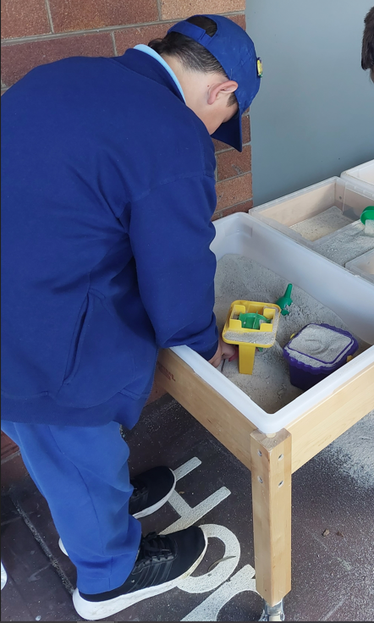

Looking ahead
Berkeley Public School will continue monitoring the goals and long-term outcomes of the Resilience Project at BPS, including reviewing Sentral incident and behaviour data, results from the Tell Them From Me survey which measures student engagement and wellbeing, and 2024 AEDC data where the school hopes to see improvements in developmental vulnerabilities across all domains.
The school will also provide further opportunities for school learning support officers to participate in professional learning to better support students with diverse learning needs. This includes children with disabilities, to continue improving student learning outcomes and strengthen the relationships with students, parents and the broader community.
For more information, contact the AEDC NSW Project Team:
Phone: 1300 083 698
Email: aedc@det.nsw.edu.au

