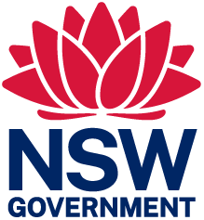 | 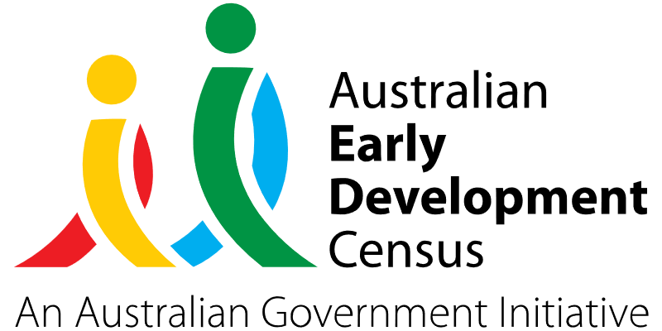

Ganandhimila-nj – We learn (Dhurga language)

Bermagui Public School

About the community
Bermagui is a town on the south coast of New South Wales, Australia in the Bega Valley Shire. Approximately 30% of the children at Bermagui Public School are Aboriginal and Torres Strait Islander children, and the school is a feeder school to Wallaga Lake, a local Aboriginal community.
Bermagui is a community with a strong connection to land and a unique arts and music culture. However, it is an area that faces high pockets of chronic health, housing, and social issues. Australian Bureau of Statistics (ABS) 2021 household income census data for Bermagui showed a lower proportion of high-income households (6.7% earned more than $3000 total household weekly income compared to 26.9% in NSW and 24.3% in Australia), and a higher proportion of low-income households (26.3% earned less than $650 total household weekly income compared to 16.3% in NSW and 16.5% in Australia).

What did the data show?
The Australian Early Development Census (AEDC) is a national measure of early childhood development that is collected at the time children commence their first year of full-time school. The AEDC collects data relating to 5 key areas of early childhood development referred to as domains. The domains are: physical health and wellbeing; social competence; emotional maturity; language and cognitive skills (school-based); communication skills and general knowledge.
The 2021 AEDC data outcomes for Bermagui Public School showed a significant increase in the percentage of developmentally vulnerable children in the ‘Language and Cognitive skills’ domain; 11.5% in 2021 which is much higher than the NSW average of 6.2% and the national average of 7.3%. Small increases in the rates of developmental vulnerability from 2018 to 2021 were also experienced across the other 4 domains.
23.3% of children in the 2021 data for Bemagui Public School identified as Aboriginal and Torres Strait Islanders. 13.3% of students were identified as having special needs status, 20.7% were identified by teachers as requiring further assessment (for example, medical and physical, behaviour management, emotional and cognitive development), and 30% of children in 2021 were marked has having high levels of absenteeism.
These AEDC findings corresponded with downward trends in teachers’ reporting that children were making good progress in adapting to the learning environment in the school context and teachers’ perceptions that parents were actively engaged in their children’s learning.
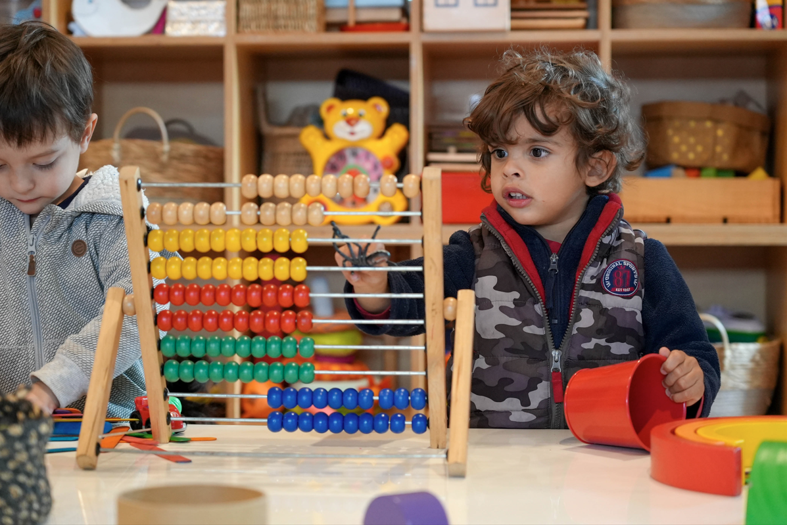

Bringing about change
Given that developmental discrepancies grow larger over time, early engagement is vital in addressing vulnerabilities across all AEDC domains. Frequently, vulnerabilities and special needs are unidentified until compulsory school age. At Bermagui Public School, educators recognised this was largely due to the fragmentation of allied health and family support service networks in the area.
The Ganandhimila-nj – We learn (Dhurga language) project’s primary objective was to support children and their families with a successful transition from Early Childhood Education and Care (ECEC) to primary school. Transition sessions were designed with a specific focus on:
- fostering positive relationships between children and teachers
- strengthening partnerships and building relationships with families
- early identification of risk factors and/or identifying children presenting with special needs
- observing and assessing children’s development, with a focus on their social and emotional well-being, and speaking/listening skills
- strengthening interagency relationships and referral pathways to engage and assess children prior to school.
Releasing teachers from front-line teaching provided a strong platform for engagement with children, families, education providers and agencies in both informal and formal settings. This included having teachers visit local feeder preschools and be there at drop-off and pick-up times to informally greet families and build points of connections. Teachers also held formal information evenings to go over details of school enrolment processes and facilitated play sessions at Bermagui Public School’s 3 feeder preschools. Teachers also informally engaged with families at Wallaga Lake through playgroup and a homework centre, which helped families get to know teachers on country and share their knowledge and aspirations about their children. Connecting with Aboriginal and Torres Strait Islander families in spaces that were familiar or on country resulted in a more positive and culturally safe platform for engagement.
The transition to school program was co-designed with the local Aboriginal community, and songs and games were also taught in the local Aboriginal language, Dhurga. Each transition session was planned to ensure a focus on speaking and listening, routines, and feeling safe and secure with teachers. The predominant purpose was to build language and cognitive skills for children, which was highlighted as a key vulnerability in the 2021 AEDC data. A strengths-based, child-centred approach was applied to ensure the program was developmentally appropriate for all children.
Following each transition visit, teachers documented observations of children’s speaking and listening skills, emotional well-being, friendships, dispositions and potential concerns. This provided teachers with the information to inform kindergarten class arrangements to best suit the needs of each child for 2023. Where preschool teachers had concerns about children’s development, this information was shared with allied health providers to provide an opportunity for earlier intervention.
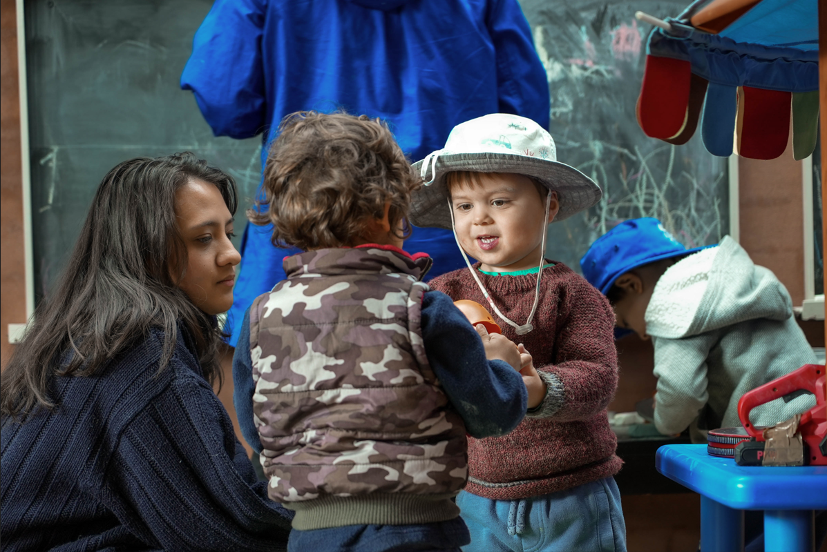

Partnerships
To implement the Ganandhimila-nj project, partnerships were developed with:
- Little Yuin Preschool and Family Centre
- Bermagui Preschool
- Little Lambs
- Australian Red Cross – place-based community development team
- Child and Maternal Health teams, and
- Bega Valley LGA and Eurobodalla LGA.

Achievements
The Ganandhimila-nj project facilitated 6 sessions in total at Bermagui Public School and 3 sessions at local feeder preschools. Qualitative data was collected via a range of platforms that provided insights into the successes of the project and future adjustments.

Children’s Voices
Ongoing consultation was facilitated with young children throughout the project. Children were continually asked questions about ‘big school’ by teachers and older children. Discussions were open-ended and captured via film. This footage was used as a point of reflection for teachers to continuously shape and build a program that responded to the needs and interests of children.
A buddy program was instrumental in supporting children to settle into the school environment. Children spent time with their ‘buddies’ during Term 4 2022 and throughout Term 1 2023. The benefits of this aspect of the program were two-fold:
- Helping young children to build relationships with older students before they commenced school; having a familiar face during the early days of school; having a buddy to help with the practicalities of being a young child such as opening your lunchbox and navigating the unfamiliar environment.
- Many older students also benefited from this aspect of the program, taking on a leadership role to demonstrate kindness. Older student frequently self-organised games for young children during playtimes, adding to the strength of the overall project.

ECEC Provider Survey
Providers overall reported that children’s social and emotional wellbeing was positive compared to transition programs in previous years. ECEC provider surveys confirmed:
- There was a positive impact on children’s emotional well-being in moving to school.
- Families reported to ECEC settings that they felt better engaged and welcomed meeting teachers informally on ECEC sites in Term 4 2022.
- Visits at ECEC settings provided an opportunity for classroom teachers and early childhood educators to build rapport.
- All providers agreed sharing practice and knowledge about children and families was invaluable.

Parent Survey
Surveys and discussions with parents or carers gathered information and perceptions about the transition process. Parent surveys confirmed there was an overall positive impact in sharing information and building relationships with children and their families. The content for the transition sessions with a focus on Dhurga language was particularly welcomed and prompted discussion about further partnerships that focus on local Aboriginal language and culture.
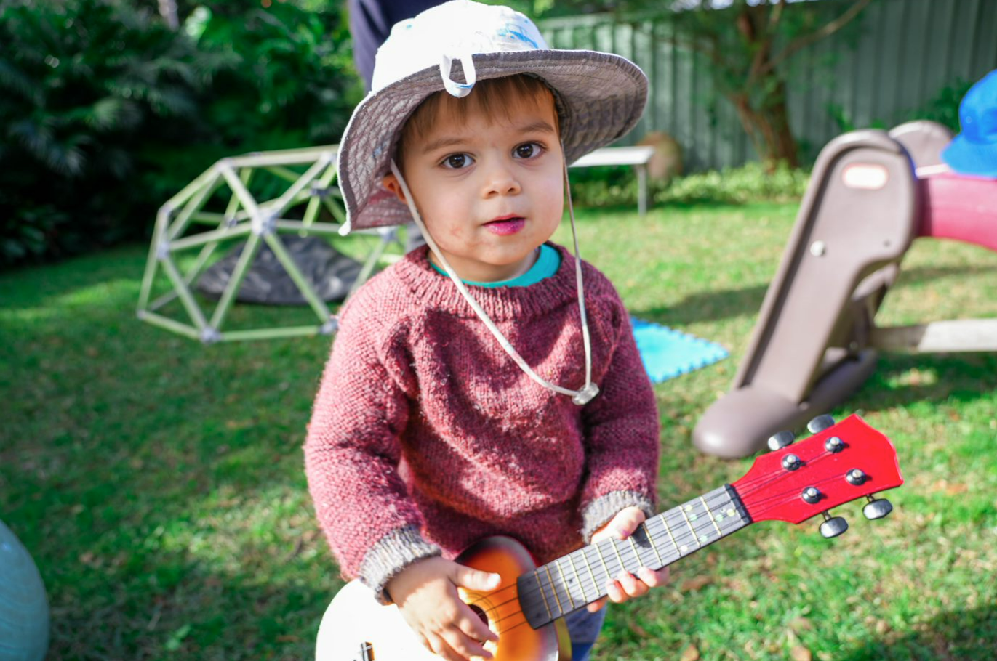

Bermagui Public School staff reflection
Having time to connect with children, families and early childhood educators was the most unanimous success of the project. The project allowed for Bermagui Public School teachers to observe and document observations of children in the ECEC and school environment and identify children with additional needs ahead of time.
By the end of the program, there was a genuine sense of excitement amongst children when they attended the school visits, indicating children were adjusting to the new environment well ahead of their scheduled ‘first day of school’. Upon commencement at school, teachers observed children being settled in the first few weeks of term. Children had already established relationships with some teachers from Term 4 2022 that fostered a sense of familiarity and security. Bermagui Public School teachers reported observations of children reconnecting with their peers, engaging in cooperative play, and demonstrating pro-social behaviours swiftly.
The Bermagui Public School Learning and Support Teacher was also able to connect with families and ECEC settings to build relationships and expedite assessment processes for children. The transition program provided additional time to observe children and put in place necessary supports into the kindergarten class from the first day of school.

Looking ahead
Bermagui Public School has identified multiple next steps to continuously improve outcomes for children and families in the school community:
- Build in-school capacity to foster connections with allied health and family support agencies to engage and support vulnerable families. This includes developing a ‘Team Around the Child’ approach that supports children and their families navigating transitions from ECEC to school and other agencies.
- Work in closer partnership with ECEC providers to share knowledge, best practice and develop a shared approach to supporting children to make a strong start to school. This includes having termly meetings with ECEC providers and early primary teachers, inviting ECEC teachers to observe in primary settings, and providing additional support for ECEC providers to expediate early assessments for children presenting with additional needs to ensure supports are in place prior to school.
- Work in closer partnership with Aboriginal and Torres Strait Islander families to build connections and culturally inclusive programs that recognise and respect the unique cultural backgrounds and needs of Aboriginal and Torres Strait Islander children. The school also hopes to seek initiatives that preserve and promote Dhurga and Djiranganj languages within the community to strengthen children’s identity and sense of belonging.
- Work in closer partnership with parents or carers, including designing a home-visit program with transitioning families and facilitating regular ‘cuppa and a yarn’ sessions in community at Wallaga Lake to informally connect with families with a focus on birth to 5 years.
For more information, contact the AEDC NSW Project team:
Phone: 1300 083 698
Email: aedc@det.nsw.edu.au

