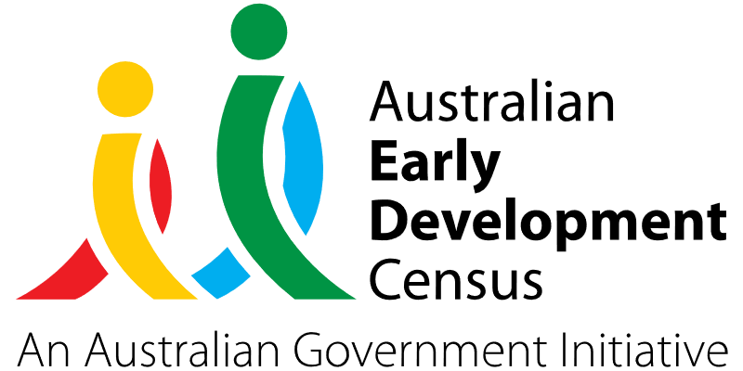

School Readiness supported by Allied Health Services

Cudal Community Children’s Centre

About the community
Cudal is a town in the Central West region of New South Wales, in the Cabonne Shire Council local government area approximately 296km west of Sydney.
Cudal Community Children’s Centre is an early childhood education and care service providing learning and wellbeing to the children of Cudal and the wider community. There are 40 children aged between 3 and 5 years enrolled in the service, and it is the only early childhood education and care service in the Cudal district.

What did the data show?
The Australian Early Development Census (AEDC) is a national measure of early childhood development that is collected at the time children commence their first year of full-time school. The AEDC collects data relating to 5 key areas of early childhood development referred to as domains. The domains are: physical health and wellbeing; social competence; emotional maturity; language and cognitive skills (school-based); communication skills and general knowledge.
2021 AEDC data for the Cargo, Cudal and Toogong area showed a 43.7% decline in children developmentally on track on the physical health and wellbeing domain (from 96.6% in 2018 to 52.9% in 2021) and a 23.5% decline in children developmentally on track on the communication skills and general knowledge domain (from 100% in 2018 to 76.5% in 2021).

Bringing about change
Given that developmental discrepancies grow larger over time, early intervention is vital in addressing vulnerabilities across all AEDC domains. At Cudal Community Children’s Centre, educators recognised that due to the lack of allied health services available in the Cudal district, an initiative focused on preparing children for school was required.
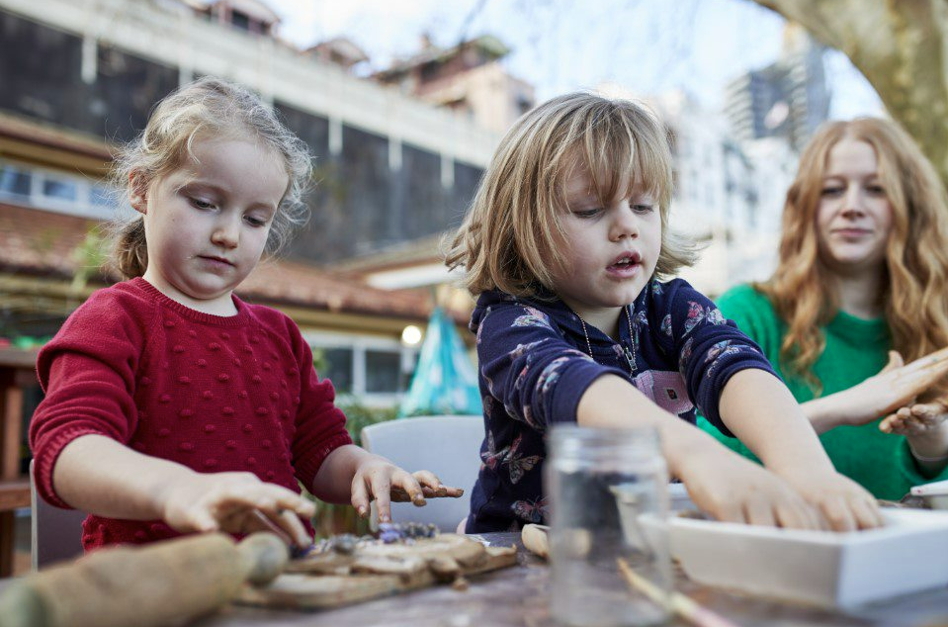
This initiative saw educators engage a speech pathologist and an occupational therapist to attend Cudal Community Children’s Centre and work with targeted children on a fortnightly basis. This provided an opportunity for families to access a service not previously available in the community. Providing speech pathology and occupational therapy services to children enrolled in the centre directly addressed the physical health and wellbeing and communicational skills and general knowledge deficiencies highlighted in the AEDC community data.

Partnerships
The initiative was run in collaboration with the principal and teachers at Cudal Public School, the Cabonne Shire Council, and Kerin Physio Co who was engaged to deliver the necessary allied health services. The neighbouring Cudal Community Centre was used as a venue to host the allied health professionals.

Achievements
Offering access to allied health services including a speech pathologist and occupational therapist has been valuable given the lengthy waiting period to receive free community health services for many families. Individualised and targeted speech pathology and occupational therapy is critical to ensure that all children reach developmental speech and motor milestones, to ensure a successful transition to school. As a result of this initiative, there have been observed improvements in the general physical health, communication skills and language and cognitive skills of the children, which the Cudal Community Children’s Centre hopes to see reflected in the next cycle of AEDC data for Cudal. In addition, there has also been an increased attendance at preschool following this initiative.

Looking ahead
Going forward, Cudal Community Children’s Centre would like to continue engaging speech pathology and occupational therapy services to work with targeted children and upskill educators to better provide for children with additional needs. Cudal Community Children’s Centre will also continue helping families build more positive attitudes towards accessing allied health professional services and facilitating a smoother transition to school.
For more information, contact the AEDC NSW Project Team:
Phone: 1300 083 698
Email: aedc@det.nsw.edu.au

