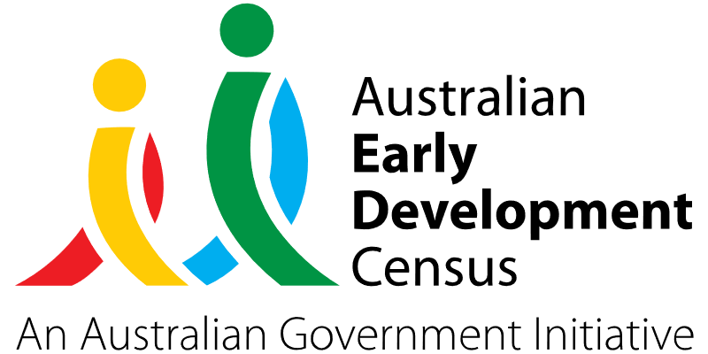

Tools and Training for Comprehensive Developmental Assessments in the Hunter Region

Early Links Inclusion Support Service

About the community
The Hunter region of New South Wales extends from approximately 120km to 310km north of Sydney and is comprised of several communities including Newcastle, Lake Macquarie, Maitland, Port Stephens, Cessnock and Muswellbrook.
Early Links Inclusion Support Service (Early Links) is a not-for-profit registered charity and National Disability Insurance Scheme (NDIS) provider that has assisted young children with developmental delays and disabilities in the Hunter region for almost 40 years. It provides immediate therapy to clients (including physiotherapy, psychology, speech pathology and occupational therapy) as well as supports to clients to access a variety of mainstream services such as community-based programs, financial and crisis support, and education.
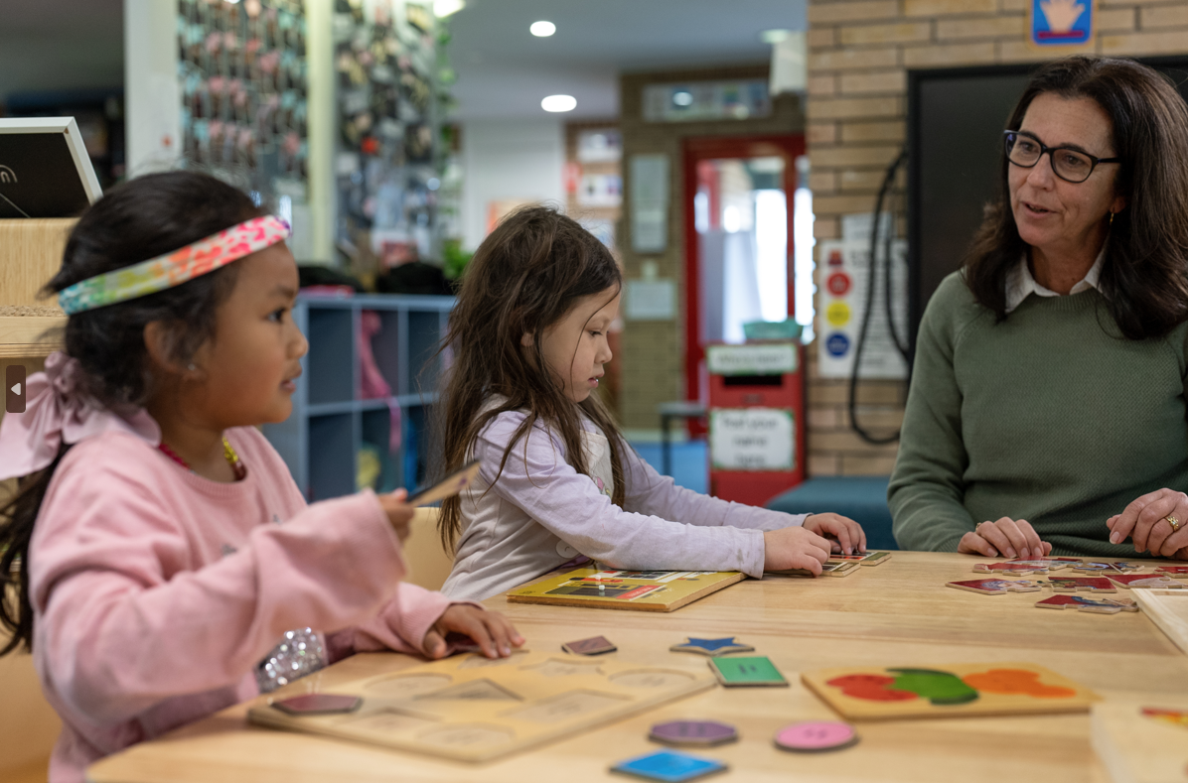

What did the data show?
The Australian Early Development Census (AEDC) is a national measure of early childhood development that is collected at the time children commence their first year of full-time school. The AEDC collects data relating to 5 key areas of early childhood development referred to as domains. The domains are: physical health and wellbeing; social competence; emotional maturity; language and cognitive skills (school-based); communication skills and general knowledge.
Developmentally vulnerable in 2021 | Physical | Social | Emotional | Language | Communication
Maitland | 12.7% | 12.8% | 10.4% | 7.8% | 8.2%
Cessnock | 15.2% | 16.1% | 10.9% | 7.2% | 10.5%
Muswellbrook | 21.7% | 15.8% | 16.3% | 14.8% | 10.3%
NSW | 9.4% | 9.4% | 7.3% | 6.2% | 8.4%
Australia | 9.8% | 9.6% | 8.5% | 7.3% | 8.4%
Since 2018, the Maitland, Cessnock and Muswellbrook communities in the Hunter region have seen an increase in vulnerabilities across all 5 developmental domains as measured by the AEDC (almost all of which were a significant increase). The level of developmental vulnerabilities for these communities captured by the 2021 AEDC data is significantly higher than both the NSW and Australian averages as summarised in the table below:

Bringing about change
Currently there are lengthy delays and wait times for families trying to attend developmental assessment appointments in the Hunter region, primarily driven by high demand and limited practitioners offering these services in the area. These wait times are particularly concerning for children with developmental delays, given the critical importance of accessing early intervention support services.
The Early Links project responded to the 2021 AEDC community data by providing families (both Early Links clients and the wider community) with access to these developmental assessments to relieve the burden being placed on other services and ensure that families received targeted early intervention support promptly.
The aim of the Early Links project was to provide developmental assessments for as many young children as possible and identify those that are developmentally at-risk or vulnerable. These children could then receive tailored support (both directly from Early Links as well as through referrals to mainstream services) with the impacts monitored over time to determine whether each child has reached the developmental milestones for their age.
The project involved using 2 comprehensive, research-based assessment tools to diagnose developmental delays and disorders in the 0 to7 age range in the Hunter region. Both the ‘Bayley-4’ and ‘Griffiths III’ assessment tools provide an overall measure of a child’s development, as well as individual profiles across many areas (aligning with the AEDC domains). These assessment tools were intended to create deep and ongoing engagement with AEDC data, with the potential to impact the lives of hundreds of children and their families in the Hunter region each year.

Partnerships
To deliver the developmental assessments, Early Links worked in partnership with Pearson Clinical Assessment Australia & New Zealand (for the Bayley-4 assessment) and the Association for Research in Infant & Child Development (for the Griffiths III assessment). Early Links also worked in partnership with families, local schools and preschools, other not-for-profits organisations (such as Hunter Prelude Early Intervention Centre and Firstchance), and local councils (Maitland, Cessnock and Muswellbrook). The services provided were supported by the NDIS and the project was supported by a wide variety of community health organisations and programs. This included parenting programs, mainstream therapy services, library programs, local playgroups, Aboriginal parent groups and community events.

Achievements
Under the Early Links Project, both the Bayley-4 and Griffiths III Assessment kits were purchased, and training was completed for 2 staff members (1 Psychologist in Griffiths III Assessments and 1 Senior Speech Pathologist in Bayley-4). Early Links was also able to provide 6 assessments (2 × Griffiths III and 4 × Bayley-4) for families that would not otherwise have been able to access these assessments due to geographical or financial barriers. Following these assessments, families were provided with a recommendation through a report and support to access NDIS funding, therapeutic interventions, and other services.
The Early Links project has seen an increase in developmental assessments occurring both within and outside of the Early Links client base. Increasing the quality and scope of assessments to differentially diagnose difficulties and reducing wait times for developmental assessments in the Hunter region has been critical in accurately diagnosing developmental delays and disorders promptly to ensure that young children receive access to early intervention support services.
Children that had been assessed and diagnosed as developmentally at-risk or vulnerable across the AEDC domains were supported in their development through the following next steps:
- Physical health and wellbeing domain – referral to physiotherapists (either external or via Early Links), Early Links group programs (such as Kids Gym, Dance Group or Sports Program), as well as other mainstream support in the community (such as GymbaROO or Kindergym).
- Social competence domain – providing opportunities to access mainstream support such as local library reading programs, playgroups (such as MyTime or Early Links playgroup), inclusive community groups and programs such as those run at Early Links branches.
- Emotional maturity domain – providing families and schools with recommendations on how to support emotional maturity in everyday activities and referrals to local programs such as yoga for kids or Early Links group programs that provide emotional regulation activities (such as Kids Gym or Dance Group).
- Language and cognitive skills (school-based) domain – providing recommendations for preschools and schools to develop language-rich environments that support the specific needs of the child (by one of the Early Link’s highly skilled senior speech pathologists), referral to speech therapy services (either external or via Early Links), and support from Early Childhood Inclusion support teachers.
- Communication skills and general knowledge domain – as above.

Looking ahead
In the long term, Early Links would like to see an increase in developmental assessments taking place in rural communities such as Muswellbrook, Scone, Denman, Dungog, Stroud, and Cessnock. While the skills and resources delivered by the grant will remain in the local area and be available as an ongoing service for children in the Hunter region, Early Links would like to extend more support to marginalised communities that have less opportunities to access such critical services.
Early Links will also continue monitoring long-term outcomes of the project, including:
- reduced wait times for developmental assessments in the Hunter region
- increased number of developmental assessments occurring within Early Links client base
- number of families accessing this service who are not existing Early Links Clients
- number of assessments taking place in rural communities
- increased early identification of developmental delays in children
- increased access to early intervention supports across all AEDC developmental domains
- increased access to other mainstream supports (for example, NDIS, inclusive playgroups, community groups)
- reduced number of developmentally vulnerable children starting school without having access to early intervention supports in the Hunter region
- reduced number of children classified as developmentally vulnerable in the Hunter region by 2024.
For more information, contact the AEDC NSW Project Team:
Phone: 1300 083 698
Email: aedc@det.nsw.edu.au

