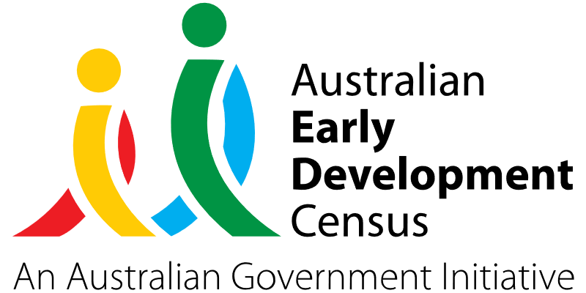

Supporting language. Supporting learning.

Gamumbi Early Childhood Education Centre

About the community
Toormina is located in the City of Coffs Harbour, on the east coast of NSW. The Australian Bureau of Statistics’ (ABS) Socio-Economic Index for Areas (SEIFA), data as at 2021, indicated that Toormina was highly disadvantaged compared to other suburbs and local government areas in NSW. 8.7% of the Toormina population identified as Aboriginal and/or Torres Strait Islander per the ABS 2021 census.
Derived from the word ‘children’ in Gumbaynggirr, Gamumbi is a small not-for-profit early childhood education centre and long day care service that is based on Gumbaynggirr land. Operating in Toormina since 1985, Gamumbi Early Childhood Education Centre has strong ties to the Coffs Coast community and caters for children from 0 to 6 years old. There are currently 89 children enrolled in the service.

What did the data show?
The Australian Early Development Census (AEDC) is a national measure of early childhood development that is collected at the time children commence their first year of full-time school. The AEDC collects data relating to 5 key areas of early childhood development, referred to as domains. The domains are: physical health and wellbeing; social competence; emotional maturity; language and cognitive skills (school-based); communication skills and general knowledge.
The 2021 AEDC data for Toormina showed a high proportion of children assessed as developmentally vulnerable in the language and cognitive skills (school-based) domain (14.3% compared to 8.8% for the wider community area, 6.2% for NSW and 7.3% in Australia).
The communication skills and general knowledge domain also showed a high level of developmental vulnerability (9.5% compared to 6.5% in Coffs Harbour, and 8.4% in NSW and Australia).
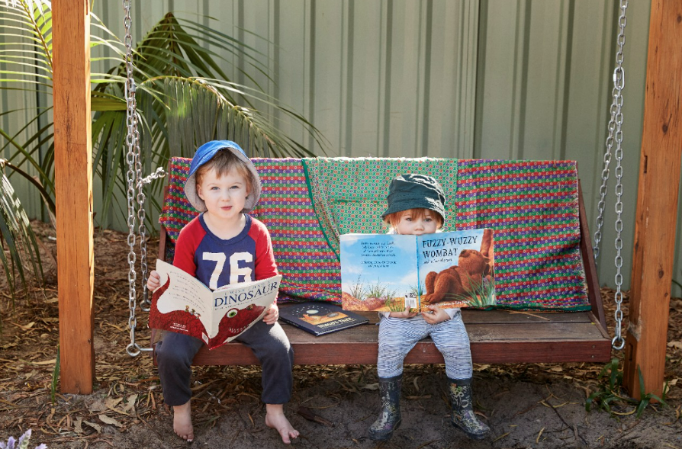

Bringing about change
Due to being a low socio-economic regional area, the Toormina community has a high level of vulnerabilities, as well as limited access to services. Currently, speech therapy can only be accessed through long waitlists in the public system or by obtaining a National Disability Insurance Scheme (NDIS) plan.
The project initiated by Gamumbi involved collaboration with Early Connections, a local service that offers early childhood intervention for children aged 0 to 6 years who have a disability or developmental delay, to develop a program addressing language and speech development. This was identified as a community need by educators through ongoing surveys and reflections and was also confirmed by the recent AEDC data.
The Gamumbi project was comprised of 3 main initiatives:
Hanen Teacher Talk workshops – releasing of educators to learn about Hanen teaching strategies to support language and communication development in early childhood settings through everyday conversations, play and daily routines, encouraging literacy development and peer interaction.
Key Word Sign workshops – implementing signs to key spoken words to support children with specific language delays so they become confident and capable communicators.
Book library – supporting families to increase literacy in the home environment by providing books and question sheets to help facilitate language development as parents read with their children.
The key focus of these initiatives was to improve language skills for children by supporting educators’ capacity in recognising vulnerabilities in children’s development, developing and implementing curriculums that support language skills and working with families to have a community approach in supporting language.
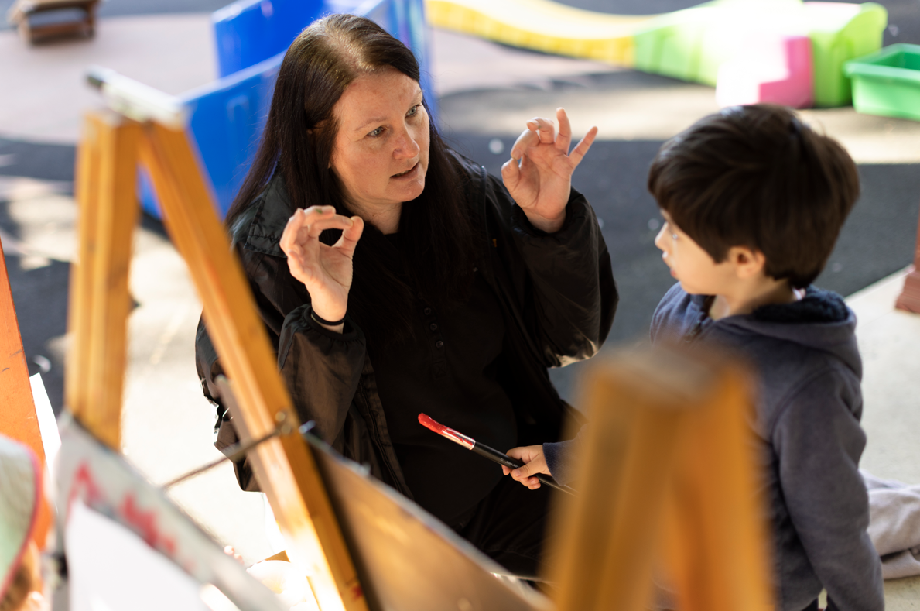

Partnerships
The project worked closely with Early Connections who delivered the ‘Key Word Sign and Hanen Teacher Talk’ training. Koori Curriculum, an Aboriginal Early Childhood consultancy that guides and supports early childhood educators to embed Aboriginal perspectives in their curriculum, was consulted to ensure all resources that were purchased for the book library were culturally safe books. Local families were also involved in the book library to ensure the library was filled with developmentally appropriate books and question sheets for all ages.

Achievements
The Hanen Teacher Talk and Key Word Sign workshops have improved the skills, knowledge, and capacity of educators at Gamumbi to support children in meeting language development milestones. The Key Word Sign and Hanen strategies have been embedded in interactions and curriculums and are also used in mentoring sessions and team meetings at Gamumbi. Weekly reflective tools have been established to ensure this new knowledge continues to be embedded and shared with new educators.
The key learnings and strategies gained from the workshops have also been shared with families and positive feedback has been received from parents who have sought more knowledge to support their children. The language needs of children have been better met through intentional interactions, environments, and programmed experiences, including music and early literacy. The book library was completed in June 2023 and Gamumbi expects to see more families borrow and engage with the selected books.

Looking ahead
Going forward, Gamumbi would like to continue engaging families by further sharing the Key Word Signs, Hanen strategies and their purpose and promoting the family library. Gamumbi would also like to engage local schools to further support the transition to school and development of language skills during this process.
For more information, contact the AEDC NSW Project Team:
Phone: 1300 083 698
Email: aedc@det.nsw.edu.au

