Confident and Capable Preschool Program

Inverell District Family Services (IDFS)

About the community
Inverell is a large town located in the northern region of New South Wales, close to the Queensland border and is the centre of Inverell Shire. The 2021 Australian Bureau of Statistics’ (ABS) census data showed that 11.1% of the Inverell Shire community identified as being of Aboriginal and/or Torres Strait Islander origin, which is significantly higher than the rest of NSW (3.4%). Inverell Shire residents have a strong connection to place which incorporates the natural, built and cultural environment. However, the Socio-Economic Indexes for Areas’ (SEIFA) score for Inverell was 2 (out of 10), reflecting a high level of socio-economic disadvantage in the area.
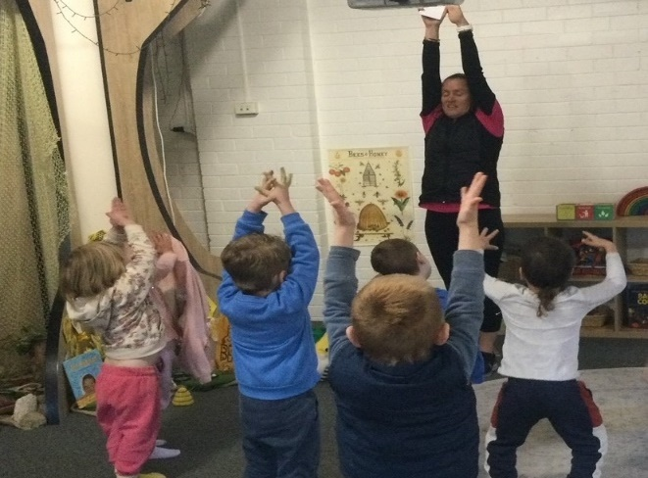
Inverell District Family Services (IDFS) is the largest not-for-profit early childhood education and care service in the New England-Northwest region. Operating within the Inverell Shire, IDFS has 9 quality early childhood education and care services, including community preschools, long day care centres, mobile preschools, outreach playgroups, family day care services and toy libraries. It supports over 700 children and 520 families in the Inverell Shire community, providing services across all social demographics with significant service delivery for low income, Aboriginal and/or Torres Strait Islander peoples, and disadvantaged children and families.

What did the data show?
The Australian Early Development Census (AEDC) is a national measure of early childhood development that is collected at the time children commence their first year of full-time school. The AEDC collects data relating to 5 key areas of early childhood development, referred to as domains. The domains are: physical health and wellbeing; social competence; emotional maturity; language and cognitive skills (school-based); communication skills and general knowledge.
The 2021 AEDC data for the Inverell community showed a significant increase in developmental vulnerabilities – 31.9% were developmentally vulnerable on one or more domain(s) (compared to 22.8% in 2018) and 14.9% were developmentally vulnerable on 2 or more domains (compared to 10.1% in 2018).
The data also indicated increasing concern in the areas of social competence, emotional maturity, and language and cognitive skills (school-based). In 2021, the combined rates of at-risk and developmental vulnerability across these 3 domains for the Inverell community were 28.7%, 28.2% and 30.9%, respectively, which are significantly above NSW state averages.

Bringing about change
The IDFS ‘Confident and Capable Preschool’ program aims to support children in the key areas of vulnerability, as identified in the 2021 AEDC data for the Inverell community, by focusing on the social competence, emotional maturity, and language and cognitive skills (school-based) domains.
It was observed by IDFS staff that children were not adapting well to change and were unable to control or regulate their emotions and build connections with peers. This increase in anxious behaviour of children was likely magnified by the impact of COVID-19 on social interactions and family units.
The ‘Comfortable Chameleons’ program was created by the Inclusion support teacher at IDFS, for children in the year prior to school, to assist in improving their social and emotional development. The program was developed based on strategies used in local schools that help children gain skills in consciously regulating their feelings by learning to identify their feelings and how to use tools or strategies to move between different feelings and emotions.
‘Comfortable Chameleons’ was designed as a 10-week program where the Inclusion support teacher, equipped with a toolbox of supplies and resources, visited each of the IDFS early childhood education and care services for an hour per week to present the program. A set of story books accompanied the program to support language development, and the toolbox of sensory tools and activity cards was used to help children and educators find the ‘right tool’ to convey their emotions. Each service also received a full set of the toolbox and resources to enable them to continue learning with children outside of the program.
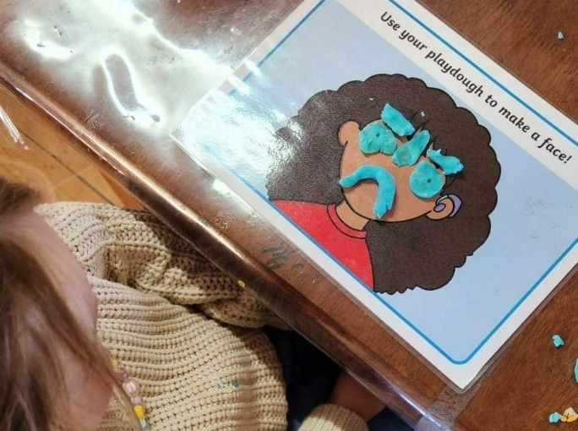

Partnerships
The IDFS ‘Confident and Capable Preschool’ program partnered and worked collaboratively with all local schools in the Inverell community, including Gilgai Public School, Gum Flat Public School, Ashford Central School, Delungra Public School, Tingha Public School, Ross Hill Public School, Inverell Public School and Holy Trinity Catholic School. IDFS engaged with the principal and primary (Kindergarten to Year 2) teachers at each school to discuss the program, implementation and evaluation.
The program was also supported by the following key partners:
Cammy Alliston – IDFS Inclusion Support Teacher
Allie Vivers, Sharon Youman and Belinda Hills – IDFS Service Managers
Lisa Reece and Sue Burdekin – Grow Community Hub Leaders
Tessa Monkton – Support Worker Centacare New England-Northwest
Bec Caskey – Key Private Occupational Therapist based in Inverell
Megan Walsh – Speech Pathologist with Hunter New England Community Health
Armajun Aboriginal Medical Service (Inverell)
Inverell Shire Council Library
Dr Janine Kinahan – Chiropractor with New England Chiropractic.

Achievements
Altogether, there were 129 children and 25 educators across 6 IDFS preschool services that participated in the ‘Comfortable Chameleons’ program. The program successfully taught children skills in how to read the facial expressions of others, recognise a broader range of emotions in themselves and others, increase their vocabulary around emotions, develop insights into events that trigger their feelings, and when and how to use tools and strategies.
A survey of educators was undertaken at the conclusion of the program in each service that ‘Comfortable Chameleons’ was implemented. All educators who participated in the program were satisfied and felt that the program met the intended outcome of improving a child’s ability to express and understand their feelings. Educators observed that children interacted with the tools and resources outside of the sessions and the language developed during the program continued to be used by children on a daily basis.
IDFS was able to provide ‘take home’ resources to families to enable them to continue building on the concepts at home with their children. Direct positive feedback was received from parents who said children were going home and talking about their feelings, how they felt in that moment and what they could use from their ‘toolbox’ to change how they felt. The program increased children’s confidence to identify their feelings and understand why they were feeling that way.
The ’Comfortable Chameleons’ program has provided the foundation for IDFS behaviour support plans for children requiring additional support, allowing IDFS to be consistent with their approach and utilise language that children understood and were able to use themselves. IDFS also created links to transition to school programs and shared the information and strategies developed in the program to children who have started kindergarten. This enables the concepts taught to follow the children so they can continue to build on their confidence and social and emotional development.

Looking ahead
In the long term, IDFS hopes to see confident and capable children engaging successfully within schools in the first years of their formal education journey, equipped with the vision to achieve their potential.
IDFS still has 3 preschools that are yet to receive the ‘Comfortable Chameleons’ program. The 10-week program is scheduled to be run at these services in Term 3 2023. IDFS is also exploring the continuation of this program in services every year with children in the year prior to school.
For more information, contact the AEDC NSW Project Team:
Phone: 1300 083 698
Email: aedc@det.nsw.edu.au

