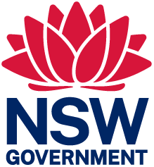 | 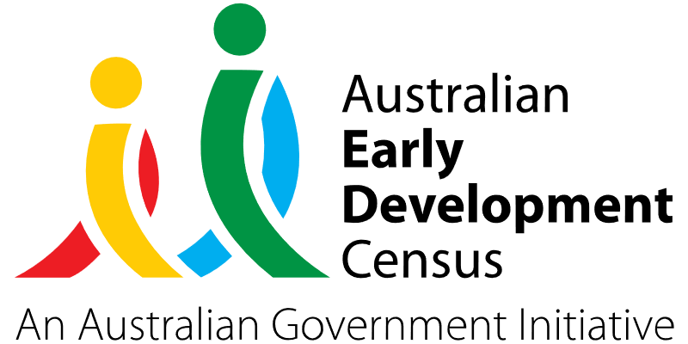

The Ripple Project Australia – children connecting through communication to their educators, parents and community

Dragonfly Speech Pathology

About the community
Tarro is a north-western suburb of the Newcastle City Council local government area in the Hunter Region of New South Wales. It has a resident population of 1,703 and is an area of high socio-economic disadvantage. The 2021 Socio-Economic Indexes for Areas (SEIFA) – Index of Relative Socio-economic Disadvantage (IRSD) gave Tarro a decile number of one in NSW, indicating it is in the most disadvantaged 10% areas in NSW.
While national data suggests that 1 in 4 children starting kindergarten may start with a speech or language disorder, the results within the Tarro suburb and surrounding areas indicates that it may be closer to 3 in 4 children that are likely to start school with a speech or communication disorder.
Dragonfly Speech Pathology is a paediatric speech pathology practice that aims to create the ripple effect of change for children with communication disorders in the areas of Newcastle, Lake Macquarie and the Hunter region.

What did the data show?
The Australian Early Development Census (AEDC) is a national measure of early childhood development that is collected at the time children commence their first year of full-time school. The AEDC collects data relating to 5 key areas of early childhood development referred to as domains. The domains are: physical health and wellbeing; social competence; emotional maturity; language and cognitive skills (school-based); communication skills and general knowledge.
2021 AEDC data for the Tarro/Hexham region showed high rates of developmental vulnerability, with 40% of children vulnerable on one or more domain(s) (16.7% in 2018) and 20% vulnerable on 2 or more domains (4.2% in 2018).
NSW’s overall 2021 AEDC results in the language and cognitive skills (school-based), communication skills and general knowledge, and social competence domains indicated significantly lower levels of developmental vulnerability compared to the Tarro/Hexham region:
Developmentally vulnerable in 2021 | NSW | Tarro/Hexham region
Language and cognitive skills (school-based) | 6.2% | 13.3%
Communication skills and general knowledge | 8.4% | 26.7%
Social competence | 9.4% | 20%
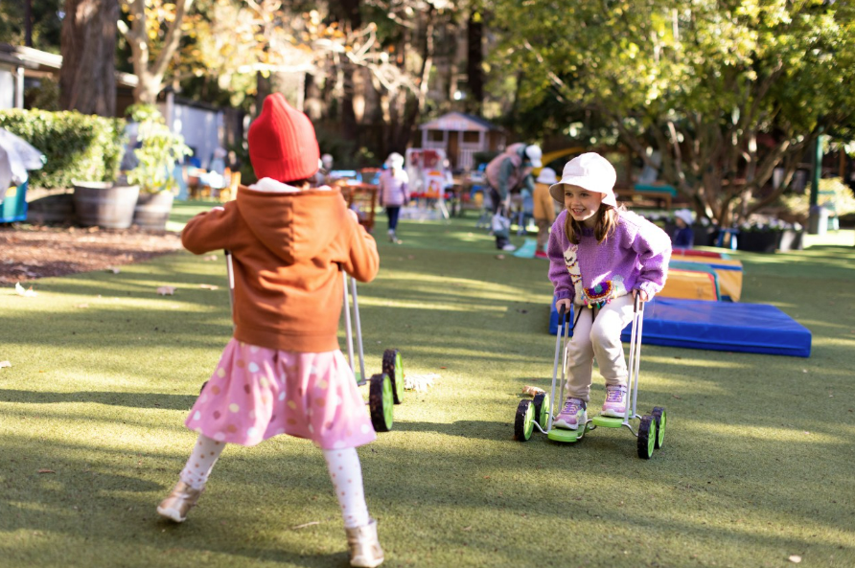

Bringing about change
The challenges for this vulnerable community are multifaceted. There are limitations within the early childhood education setting that prevent children from being identified as at risk of poor communication and general knowledge at this crucial early intervention stage. Upon discussion with partners, several key barriers to children getting the help they need in the earlier preschool years were identified for the area:
- Early childhood educators and teachers do not know when to raise concerns with the parents or concerns are raised too late.
- Early childhood educators and teachers being uncertain about how to discuss their concerns with parents or not knowing what to recommend.
- Early education centres can have a high staff turnover, so educators do not get to know the children well.
- Early education centres run on a very tight budget and often do not have access to professional learning for all staff.
The Ripple Project Australia led by Dragonfly Speech Pathology aimed to overcome the above barriers by developing short educational videos about speech, language and communication milestones, how to talk with parents, and how to create a language-and-interaction rich environment that will support 3 out of 5 AEDC domains. These resources empower early childhood educators with the knowledge and skills to identify and support speech, language and developmental differences in children.
This was intended to create a ripple effect of getting help sooner for the children that need it, as many schools found that even with successful transition programs operating, the delays in accessing services to support speech and language development are quite lengthy and often unobtainable during the period prior to school entry. As the videos will be recorded and accessible online, this will be useful for the preschools as the videos can be watched and used for new staff training or refresher training.

Partnerships
The Ripple Project Australia was developed by 2 experienced speech pathologists at Dragonfly Speech Pathology and created in collaboration with Tarro Public school and 2 early education services: Beresfield Community Children’s Education Centre and Woodberry Community Preschool. Both services are feeder centres to Tarro Public and other schools within the Gateway Learning Community. Working closely with these schools meant that the educational topics were relevant and relatable to this community. The speech pathologists were able to film within the early education centres, which enabled real-life video and sound examples of children with a communication delay.
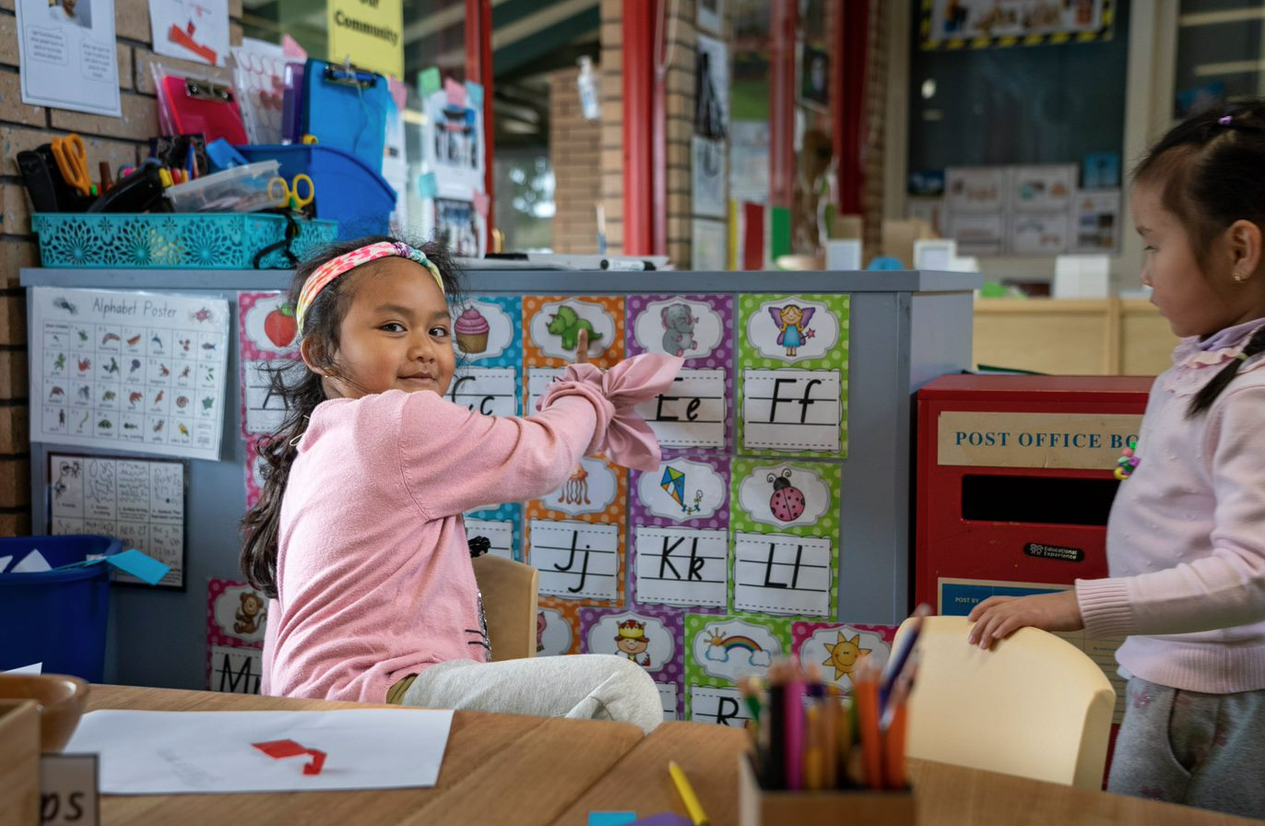
It promotes and supports the notion that parents and carers working in collaboration with the school and early childhood centres will form authentic partnerships that support academic, social, emotional and cultural growth for all.
The project was delivered alongside the following key partners:
- Dragonfly Speech Pathology – Amy Pollitt, Certified Practising Speech Pathologist (CPSP) Senior Speech Pathologist
- Communicating Kids – Ruth Davies, Director, Senior Speech Pathologist
- Tarro Public School –Kelly O’Shea, Principal
- Gateway Learning Community – Carolyn Wilson, Assistant Principal Transition Support Teacher – Early Years
- Beresfield Community Children’s Education Centre – Jacqueline Mills, Director
- Woodberry Community Preschool – Michelle Curtin, Director.

Achievements
The 2 early education centres participating in The Ripple Project Australia were asked to complete 6 courses. All courses were available online and were designed to be watch in small units, ranging from 10 to 20 minutes. In total, there were 7 hours of professional learning available. The 6 courses were:
- Allied Health; What do they do?
- Speech and Language Milestones
- Speech and Language Screener for Early Education Centres
- Parents and the Referral Process
- Early Literacy Skills for Pre-schoolers: Going Beyond the ABC’s
- Supporting Speech and Language Delays: How Can I Help?
All of the early childhood educators that participated in The Ripple Project Australia were asked to complete a pre- and post- questionnaire. The questionnaire used a Likert scale, closed questions and open-ended questions to measure the early educator’s knowledge and experience prior to completing the training and again, after completing the training.
Overall, the educators that completed all 6 courses indicated that after completing the courses, 75% now felt confident in the skills they had to help a child build their speech and language skills, compared to only 36% prior to the completion of the training. All of the educators that completed all 6 courses indicated that this project would improve the lives of children with a communication disorder in their centre.
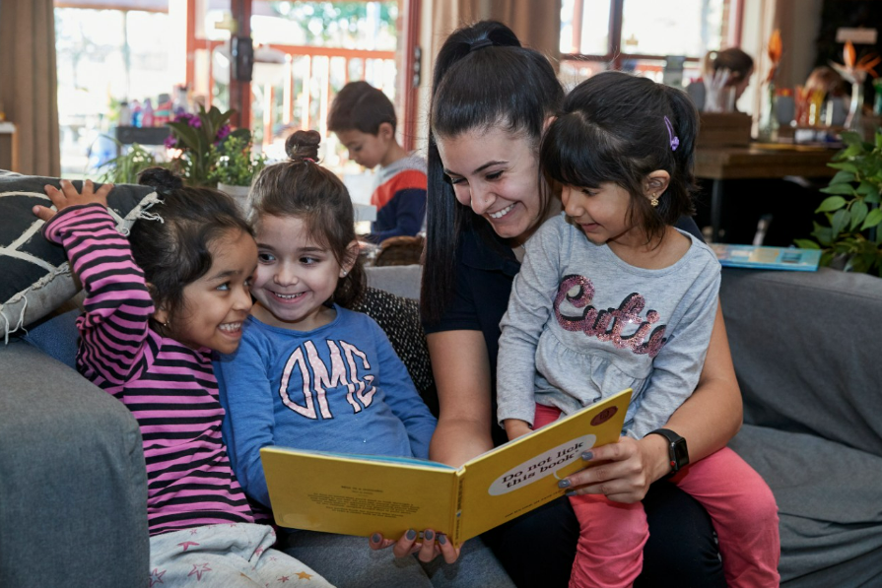
Another area of success was informing educators about the referral pathways and funding options for speech pathology and other allied health disciplines. The post-questionnaire indicated that 93% of educators/respondents were now aware of the referral pathways, compared to 21% in the pre-questionnaire. Educators also felt more confident in speaking with parents about speech and language milestones and knowing how to have positive conservations with parents about potential delays.
All of the early childhood educators indicated that they would recommend The Ripple Project Australia to other early childhood educators.

Looking ahead
The results of the pre-and post-questionnaire have indicated that ‘The Ripple Project Australia’ training was successful in improving early childhood educators’ knowledge and awareness around speech and language milestones and how to support children with a communication delay in their centre.
As well as seeking opportunities to offer this training to more centres across NSW in future, The Ripple Project Australia would like to create courses that are targeted and delivered to parents as well as early childhood educators. So far, the focus has been on early childhood educators; however, expanding the availability of the course to parents may also allow children to access much needed services earlier and to improve the language outcomes in the home environment. This would in turn create a bigger ripple effect of change for the vulnerable children in the community.
For more information, contact the AEDC NSW Project Team:
Phone: 1300 083 698
Email: aedc@det.nsw.edu.au

