Schools as Community Centre (SaCC) in partnership with Woodberry Public School and local community services

Early Access for Success Program

About the community
Woodberry is one of the easternmost suburbs of the City of Maitland in the Hunter Region of New South Wales. It is located approximately 160 km north of Sydney and 23 km north-west of Newcastle.
The Woodberry population lives in residential subdivisions while almost 84% of the suburb's land is rural in nature. The Woodberry community has limited access to services. The latest Socio-Economic Indexes for Areas (SEIFA) – Index of Relative Socio-economic Disadvantage (IRSD) has Woodberry in the lowest scoring 20% of areas, and it has been given a quintile number of 1 or the most disadvantaged. This is further impacted by barriers existing within and across the community that restrict children’s access to appropriate early intervention and medical services. Fifty per cent of children starting school did not attend an early childhood education and care service, and most children have not had contact with a child and family health nurse.

What did the data show?
The Australian Early Development Census (AEDC) is a national measure of early childhood development that is collected at the time children commence their first year of full-time school. The AEDC collects data relating to 5 key areas of early childhood development referred to as domains. The domains are: physical health and wellbeing; social competence; emotional maturity; language and cognitive skills (school-based); communication skills and general knowledge.
According to 2021 AEDC data, the Woodberry community has a high level of vulnerability – 75% of children were vulnerable on one or more domain(s), and 53% were vulnerable on 2 or more domains. The AEDC data showed significantly high rates of vulnerability in all domains and no significant improvement since the 2018 census in rates of at-risk or developmental vulnerability. In 2021, the combined rates of at-risk and developmental vulnerability across the 5 domains for the Woodberry community were as follows:
- communication skills and general knowledge: 72%
- emotional maturity: 72%
- social competence: 69%
- language and cognitive skills (school-based): 60%
- physical health: 56%.
The 2021 AEDC school and community data correlates with other assessments and observations made by teachers, child and family health nurses, early childhood educators and families. Consistent with AEDC data for Woodberry, recent speech and language screening revealed that 85% of the kindergarten cohort had a diagnosed speech and language disorder or difficulty that would impact learning.

Bringing about change
The AEDC results indicated a gap in access to strategic, collaborative partnerships and programs to identify, assess and provide early intervention for children aged from 0 to 5 years, prior to formal schooling. These first 5 years of a child’s life are crucial years for brain development and building the foundations for future learning.
The ‘Early Access for Success’ program addressed these findings by implementing early identification and assessment to support families to access early intervention. The program responded to the AEDC data by reducing socio-economic barriers to early intervention and providing support for children who are considered developmentally vulnerable or at risk.
By seeking early access to screenings, assessments and early intervention programs to identify those that are developmentally ‘not on-track’, this ensures that these children receive early support to become developmentally ‘on-track’ prior to starting school, giving them the best opportunity to thrive.
The Early Access for Success Program was implemented in 3 stages:
- Stage 1: Developmental Screening – Ages and Stages Developmental Questionnaires, speech and language screening, Early Years Education-Direct Assessment screening tool for school readiness through SaCC playgroups, local early childhood education, and care services and teachers during the transition to school program
- Stage 2: Referral for Support – Hunter New England (HNE) Health, community services and National Disability Insurance Scheme (NDIS) – Early Intervention.
- Stage 3: Access:
- Tier 1: delivered universal programs – speech program during school transition programs and local playgroups
- Tier 2: engaged external services to provide assessment and reporting (speech pathologists, occupational therapists, physiotherapists, psychologists) to support applications for NDIS funding
- Tier 3: provided funding and subsidised costs for vulnerable children to access paediatric assessments and reporting more quickly through the private system.
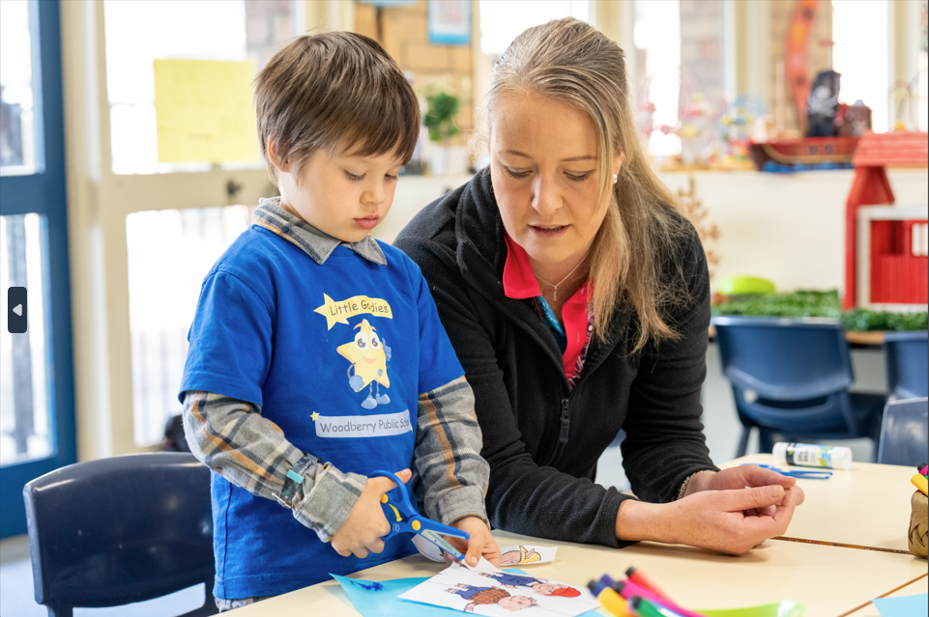
The program also enabled staff to upskill their own professional capabilities required for their role. As a result, it strengthened their skills and confidence to communicate with families about children’s learning, development and wellbeing.

Partnerships
The success of the Early Access for Success program was achieved through collaborative partnerships with multiple government and non-government agencies, services, schools, local councils and community groups, including:
- Woodberry, Beresfield and Tarro Public Schools
- Maitland Family Support
- Maitland Neighbourhood Centre
- Hunter New England (HNE) Health – Child and Family Health Nursing Services
- HNE Health – Speech Pathology – Head of Discipline
- Gateway Learning Community (GLC) – Assistant Principal and Transition Support Teacher
- Mindaribba – Local Aboriginal Land Council
- Playgroup NSW – MyTime Playgroup
- Fair Play Out of School Hours (OOSH) – Woodberry
- The Rutherford Telarah Rotary Club
- Awabakal Aboriginal Medical Service
- EquiEnergy Youth
- Samaritans Child and Family Support.
The program utilised a SaCC setting as a base, as it was already recognised in the community as a safe space, where children and families were welcomed and supported. Referrals and access were made through collaborative partnerships and via the Transition Support Teacher, local early childhood educators and centre directors.

Achievements
The Early Access for Success program has led to an increase in children receiving assessment and intervention, and a reduction in the time a child waited for support once vulnerabilities were identified. Aboriginal and/or Torres Strait Islander children who are part of 9.6% of Woodberry’s population (compared to 2.9% for NSW and 2.8% for Australia) have gained increased access to services, and there has been an overall increase in children being screened for developmental vulnerabilities.
The program has been effective in addressing and mitigating behavioural issues among kindergarten students, leading to more positive and supportive learning environments. These behavioural improvements were reflected in Sentral data on wellbeing and behavioural incidents. In 2022, before the program was introduced, Sentral data showed a high number of negative incidents, with 189 incidents occurring in the first 5 weeks of kindergarten. Following the introduction and implementation of the Early Access for Success program, the number of reported behavioural incidents reduced significantly to only 25 negative incidents in the first 6 weeks of 2023. This represents an 86.7% reduction in negative incidents compared to the previous year.
The collaborative partnerships as part of the program have resulted in more children reaching developmental milestones and having the functional skills required to make a successful start to school. By increasing family and educator knowledge about ‘red flags’ for potential developmental issues and establishing connections to practitioner specialists through the school, children have been able to receive early identification, referral and support when needed, helping them stay on track for healthy development. The school has also been able to gain an evidence-based perspective on every child to prepare appropriate learning goals and environments.

Looking ahead
Following on from the success of the current program, the Early Access for Success screening program has been extended to preschool settings to allow children to be screened at an earlier age compared to the traditional transition to school screening age. By implementing screenings at the preschool level, the program can now identify and support a broader segment of the transition cohort that may have previously been missed.
To further enhance AEDC outcomes for children in the community, the next crucial step is to integrate the Early Access for Success program seamlessly into the Woodberry ‘Strong Stars’ transition to school program. By combining successful practices, multidisciplinary support, early intervention, community engagement and continuous scaling of evidence-based methods, the initiative can create a positive and nurturing environment for children's development, leading to improved outcomes as they progress into formal education and beyond.
For more information, contact the AEDC NSW Project Team
Phone: 1300 083 698
Email: aedc@det.nsw.edu.au

