2022 Inclusion Forum
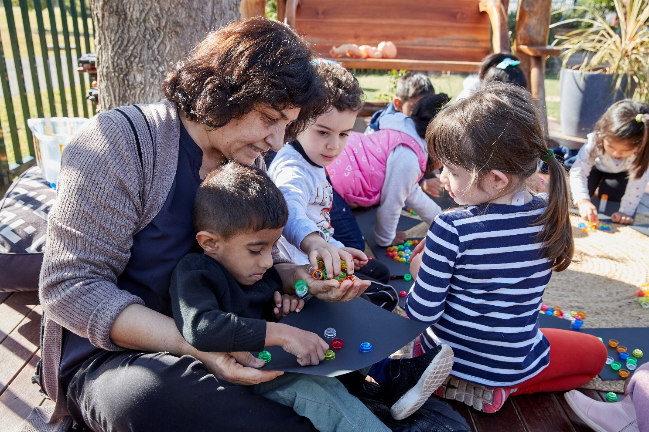

Attendee pack

How to engage with this pack
The focus of the 2022 Inclusion Forum is to promote high quality early childhood education that raises learning outcomes and reduces the impact of disadvantage. As you engage with the presentations, you can use this pack to guide your thinking, reflections and plans for future action. The components of the pack can be printed double-sided or used digitally.
In this pack, you will find note-taking pages that complement each presentation, as well as a final reflection tool to help you implement change.
The note-taking pages feature focus questions specific to the content of each session. They also provide you with the opportunity to record your key take-aways and ideas.
The reflection tool is a summative activity that supports you to consider your learning from the 2022 Inclusion Forum. It is a great opportunity to collaborate with other colleagues in your service or school to promote lasting and meaningful change.
Contents
2022 Inclusion Forum 1
Self-regulation 3
Self-regulation Q&A session 5
Tuning in to the needs of young children with disability or delay 7
Building a more inclusive education system in NSW 9
Conscious, curious, connected and calm 11
Effective practice for children and families from refugee backgrounds during transition to school 13
Practical and effective transition strategies for supporting students on the autism spectrum 15
Reflection tool 17

Self-regulation
Dr Stuart Shanker
Focus questions
- What are your reflections about the stress that children can experience?
- How could you co-regulate more effectively with children?
Key points: | Notes:

Key points: | Notes:
Summary
The 3 key ideas that I’d like to apply to my practice:
1.
2.
3.

Self-regulation Q&A session
Susan Hopkins
Focus questions
- What are your reflections about the stress that children can experience?
- How could you co-regulate more effectively with children?
Key points: | Notes:

Key points: | Notes:
Summary
The 3 key ideas that I’d like to apply to my practice:
1.
2.
3.

Tuning in to the needs of young children with disability or delay
Dr Sarah Carlon
Focus questions
- How might you change your current practices around planning for a child with disability or delay?
- How can you make planning for children with a disability a more collaborative process?
Key points: | Notes:

Key points: | Notes:
Summary
The 3 key ideas that I’d like to apply to my practice:
1.
2.
3.

Building a more inclusive education system in NSW
Louise Farrell and Amber Mackay
Focus questions
- How do you currently support children to feel a sense of belonging in your setting?
- What steps can you take to respond to the new policies and resources for inclusive, engaging, and respectful schools?
- How could you strengthen your collaboration with other services and agencies to support an inclusive transition pathway?
Key points: | Notes:

Key points: | Notes:
Summary
The 3 key ideas that I’d like to apply to my practice:
1.
2.
3.

Conscious, curious, connected and calm
Kate Norman
Focus question
- Are there opportunities for you to embed mindfulness practice with the children in your setting?
Key points: | Notes:

Key points: | Notes:
Summary
The 3 key ideas that I’d like to apply to my practice:
1.
2.
3.

Effective practice for children and families from refugee backgrounds during transition to school
Rachel Hennessy and Rosemary Signorelli
Focus question
- What will you do differently when supporting the transition of children who have experienced trauma?
Key points: | Notes:

Key points: | Notes:
Summary
The 3 key ideas that I’d like to apply to my practice:
1.
2.
3.

Practical and effective transition strategies for supporting students on the autism spectrum
Lee Casuscelli
Focus question
- How can you ensure that you are using a strength-based approach in planning for a child’s transition into school?
Key points: | Notes:

Key points: | Notes:
Summary
The 3 key ideas that I’d like to apply to my practice:
1.
2.
3.

Reflection tool
This reflection tool supports you to consider your learning from the Inclusion Forum and shift your thinking from understanding to action.
What I can do to implement change:
In my own room or classroom | In my service or school | In my community or educational networks

