Teacher resource: Culturally responsive practice - supporting Aboriginal children and families
This teacher resource accompanies the professional learning session ‘Culturally responsive practice: supporting Aboriginal children and families’. It may be used to support professional dialogue to facilitate deeper understanding within the preschool team or to supplement the corresponding professional learning.

Purpose
The purpose of this resource is to support educators to embed culturally responsive practice, maximising learning outcomes for Aboriginal children and families in the early years.

Key messages
The early years are an important time for children to:
- build a strong cultural identity
- build resilience
- grow up deadly, healthy and strong.
By providing a space where culture is acknowledged, and children and families feel safe it is more likely that these benefits will be realised.
Family is the cornerstone of Aboriginal and Torres Strait Islander culture, spirituality and identity. As an Aboriginal and Torres Strait Islander child grows up, maintaining their connections to family and community forms the basis of the development of the child's identity as an Aboriginal and Torres Strait Islander person, their cultural connectedness and their emerging spirituality (Source: Priest, K. 2005, Preparing the ground for partnership—exploring quality assurance for Aboriginal and Torres Strait Islander child care: a literature review and background paper, Department of Family and Community Services, Government of Australia).

Key drivers of Aboriginal education
A range of national and state policies, reports and strategies exist in relation to Aboriginal education in the early years. All identify that when high quality, culturally inclusive early childhood education services and schools work with families and communities this sets a strong foundation for early learning, including a child’s transition to school.
Key policy drivers include:
- Closing the Gap targets
- The National Aboriginal & Torres Strait Islander Education Strategy 2015
- The Alice Springs (Mparntwe) Education Declaration (2019)
- The Aboriginal Education Policy and support document Turning Policy into Action PDF979KB)
- The Premier’s Priorities
The Department of Education Strategic Plan 2018-2022 complements the existing Aboriginal education documents/policies by ensuring:
- children are at the centre of all decision making
- every child is known, valued and cared for
- an increased proportion of Aboriginal students in the top two NAPLAN bands for reading and numeracy.

Common threads and key themes can be identified throughout all Aboriginal education documents and it is recommended that educators read and become familiar with these documents.

Definitions
Defining the words below allows us to have a common understanding and be on the same page when discussing or reading about culturally responsive practice.

Cultural Competency
Cultural competency is ‘the ability to understand, communicate and effectively and sensitively interact with Aboriginal and Torres Strait Islander students, families, communities and staff.’ (Source: Australian Institute for Teaching and School Leadership (AITSL). Indigenous Cultural Competency in the Australian Teaching Workforce, Summary Report of Initial Consultations, December 2019 p. 3).

Cultural safety (in an educational context)
Cultural safety is:
the provision of a learning environment that is conducive to the diverse learning needs of Aboriginal and Torres Strait Islander students and where the children’s culture and identity are visible and valued (Source: Australian Institute for Teaching and School Leadership (AITSL). Indigenous Cultural Competency in the Australian Teaching Workforce, Summary Report of Initial Consultations, December 2019 p. 9).

Protocols – ways of working together
Protocols are appropriate ways of behaving, communicating and showing respect for diversity of history and culture. This involves appreciation of the knowledge, standing and status of people within both the local Aboriginal and school community. Protocols will vary between communities, and between people within communities. In establishing a partnership between schools and Aboriginal communities, it is important that protocols are acknowledged and respected.
Some commonly observed broad protocols within Aboriginal communities:
- respect for Elders in decision-making processes
- collective custodianship by traditional owners and keepers of Country and cultural knowledge
- the right to observe cultural responsibilities and obligations, for example, to care for Country and to pass on cultural knowledge.
By ensuring that protocols are observed, educators can ensure that the process of community consultation is successful and beneficial to the whole school community.

The cultural competence continuum
The cultural competence continuum tracks the various stages that work towards cultural competence. The stages range from cultural destructiveness through to cultural proficiency.
In this model, cultural competence is characterised by:
- acceptance and respect for difference
- continuing self-assessment
- careful attention to the dynamics of difference
- continuous expansion of knowledge and resources
- adaption of services to better meet the needs of diverse populations.
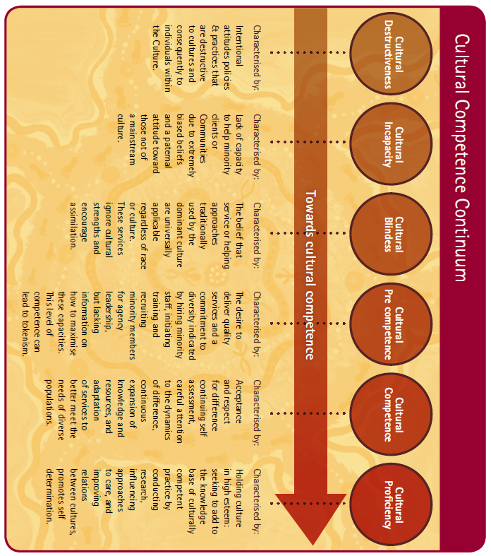Source: Victorian Aboriginal Child Care Agency (VACCA) Building Respectful Partnerships: The commitment to Aboriginal Cultural Competence in Child and Family Services
The purpose of using this assessment tool is to help identify where your service is at, and what could be improved to provide a culturally competent service.

Engaging families and community
Collaborative relationships with families are fundamental to achieving quality outcomes for children. Parents, carers and families are the ﬁrst and most important educational inﬂuence in a child’s life. They have a critical role in early development, including social, emotional, intellectual, spiritual and physical wellbeing (Source: Alice Springs (Mparntwe) Declaration, p.6).
Observing respectful and appropriate protocols when working with Aboriginal families and communities is critical to establishing positive relationships. Consultation should be seen as a two-way process not one of self-interest.
In NSW, the Aboriginal Education Consultative Group (AECG) is the peak Aboriginal advisory body to the Department of Education. A Partnership Agreement is in place that outlines how the NSW AECG and the Department of Education are planning on working together. Agreed priority four is:
Ensuring that Aboriginal children have skills for learning by the time they start school by providing access to a variety of relevant and culturally inclusive prior to school and preschool programs (Source: Together we are, Together we can, Together we will Partnership Agreement 2010 – 2020 p. 4).
NSW local and regional AECGs are able to provide advice and guidance for educators about the delivery of curriculum in government and non-government schools. While not all schools have access to a local AECG, the AECG Secretariat is able to provide details of the nearest group. They can be contacted by phoning (02) 9550 5666 or checking their website.
Supporting effective teaching and learning

Personalised Learning Pathways (PLP)

PLPs are an effective tool for increasing Aboriginal student engagement. They have the potential to support improved learning outcomes for children when they are developed in genuine partnership with Aboriginal children, families and educators.
The PLP document is used by schools to ensure Aboriginal students and their parents/carers are actively engaged in meaningful planning and decision-making in education. PLP conversations are of great importance as they identify and strengthen shared understandings of goals, expectations and responsibilities. These conversations need to be respectful and genuine (Source: Personalised Learning Pathways Guidelines pp.2-4 (PDF 262KB)).

Linking to the curriculum
The Early Years Learning Framework asks early childhood educators to build upon children’s understandings of diversity, specifically Aboriginal and Torres Strait Islander cultures. Understanding, valuing and supporting Aboriginal and Torres Strait Islander culture not only supports inclusion for Aboriginal and Torres Strait Islander children but strengthens awareness of culture for all children.

Principle: respect for diversity
Educators show respect for diversity when they:
- provide opportunities in the curriculum that reflect diversity as well as reflecting practices, values and beliefs of children and families
- value children's different capacities and abilities, and respect differences in families' home lives.

Practice: cultural competence
To be culturally competent, educators:
- respectfully acknowledge multiple cultural ways of knowing, seeing and being
- display positive attitudes towards cultural differences
- take a personal responsibility to build their knowledge, understanding and attitude
- successfully work and communicate with children, families and community members.

Outcome 1: Children have a strong sense of identity

Being proud and strong
Educators intentionally promote this learning when they:
- show genuine respect for all children and their ways of belonging, being and becoming
- provide many opportunities for children to interact with culturally valued skills, languages, stories, dance, food and crafts of their families and community
- model language to describe and celebrate the culture of the community in first languages and Standard Australian English
- design an environment that enables children to make choices and decisions about their play and resources.

Outcome 2: Children are connected with and contribute to their world

Mob, Country and community
Educators intentionally promote this learning when they:
- expose children to resources that broaden their appreciation of diversity, for example, artefacts, dance, music, languages and dialects, stories, art and craft of other cultures
- provide culturally sensitive choices and alternatives for children to regulate their behaviour
- invite Elders and community members to share aspects of the children’s relationship to the physical world, for example, through songs, dance and storytelling children explore land, water, air, bush, sky, rocks and weather patterns.

Outcome 3: Children have a strong sense of wellbeing

Being healthy, deadly and strong
Educators intentionally promote this learning when they:
- take time to engage in enjoyable and trusting conversations with children and families
- invite Elders and community to share stories with health and safety messages
- incorporate songs, games, music, stories and information technologies in Standard Australian English and first languages that support healthy lifestyles and nutrition
- implement specific health and safety programs for children in collaboration with families and communities, for example, the Blow Breathe Cough (BBC) routine for Otitis media.

Outcome 4: Children are confident and involved learners

Being deadly, talking up loud and having a go
Educators intentionally promote this learning when they:
- have high expectations of children’s capabilities
- allow children to direct their own learning
- focus on children's strengths, rather than on what they can't do, in all interactions and activities
- provide open-ended, play based learning opportunities where children can direct their own learning.

Outcome 5: Children are effective communicators

Yarning up
Educators intentionally promote this learning when they:
- know about, recognise and support the development of children’s first language as well as Standard Australian English
- provide games, dance and movement experiences that involve simple directions and instructions
- provide opportunity for oral story telling
- incorporate cultural events, symbols and experiences that involve patterns of repeated sequences, for example, in movement, songs, art, games, dance, manipulative play, routines and stories.

Practical tips for everyday practice
The following are practical ways to include Aboriginal perspectives in an authentic way in everyday practice within the school and/or preschool.

Identify the local community
- Find out who the Traditional Custodians of your area are and the language spoken.
- After discussions between Aboriginal families, educators and children, map children’s Country and language group.
- Acknowledge Country with the children everyday by relating the history of the land to the experiences of children and their environment.
- Invite community visitors and Elders to the service to share their skills or knowledge with the children, for example, storytelling or traditional music.

Localise the curriculum
- Strengthen children’s sense of identity by reading books and singing songs in language.
- When introducing stories or artwork from other parts of Australia, talk about whose mob the story or artwork comes from and use the Aboriginal Australia map to illustrate this.
- Reflect the local language in signs around the preschool so everyone knows that your service is a culturally safe place.
- Find out what community dates and events are celebrated in your local area.
- Reflect the natural environment in the playground by including native plants from the local area.

Identify with Aboriginal culture in your environment
- Learning environments should reflect the local natural environment. For example, using natural materials from local beach or bush habitats to help children feel connected to the land and their local culture.
- Display the Aboriginal and Torres Strait Islander flags. The flags may be flown or displayed throughout the year. Tokenism can be avoided by firstly explaining to children what they are, what they represent and the meanings of the flags.
- Use Aboriginal resources in teaching and learning activities.
- Use local artwork from local artists bought from reputable, ethical sources.
- Use red, black and yellow colours in displays. Discuss the meanings of the colours with the children.
- Provide access to a wide range of natural and manufactured materials and resources such as clay, rocks, pebbles, sand, water, fabrics, palm leaves, feathers, shells, driftwood, wood, fibres, ochre, natural dyes and pigments.

Put a cultural spin on everyday activities
- Share and read Dreaming stories with children.
- Use oral story telling.
- Grow traditional bush tucker foods in your garden and use these in cooking activities with children.
- Provide implements to draw in sand or dirt or use sticks and leaves as painting mediums.
- Use native herbs such a lemon myrtle of wattle seed in playdough.
- Make and paint with ochre.

Questions for reflection
Critical reflection involves closely examining all aspects of events and experiences from different perspectives. Following are some overarching questions to guide reflection about culturally responsive practice.
- How are you including Aboriginal perspectives within the school plan and preschool Quality Improvement Plan?
- How do you ensure all children learn about Aboriginal culture, histories and experiences?
- What evidence is there of a culture of high expectations and community engagement, resulting in improved educational outcomes for Aboriginal learners?
- Use the cultural competency continuum to reflect on what stage you and/or your service is at. What measures could you take to move towards cultural competency and beyond?
- How do you include Aboriginal parent voices in the program?
- How does your service show you value Aboriginal culture and create a safe space for families?
- How are the children in your setting encouraged to feel strong and proud of their culture?
- How are high expectations for each Aboriginal child reflected in planning and everyday practice?
- Does every Aboriginal child have a PLP that is developed in genuine partnership between themselves, their families and educators?

Resources
Following are some quality resources to support educators’ culturally responsive practices.

Working with families
NSW Education Standards Authority (2008) Working with Aboriginal communities: A guide to community consultation and protocols (PDF 1.67MB)
Reconciliation Australia Narragunnawali: Reconciliation in Education
The State of Queensland Department of Education Foundations for Success: Learning, Teaching, Leading
Emerging Minds Working with Aboriginal and Torres Strait Islander families and children
Emerging Minds Working and walking alongside first nations children and young people- a practical guide for non-Aboriginal workers
Secretariat of National Aboriginal and Islander Child Care (2011) Growing up our way: Aboriginal and Torres Strait Islander child rearing practices matrix (PDF 2MB)

Curriculum resources
Secretariat of National Aboriginal and Islander Child Care Introduction to the EYLF Fact Sheets (PDF 6.71MB)
Secretariat of National Aboriginal and Islander Child Care The journey to big school – supporting Aboriginal and Torres Strait Islander children’s transition to primary school (PDF 1.17MB)
Secretariat of National Aboriginal and Islander Child Care Deadly resources for quality services (PDF 623KB)
Secretariat of National Aboriginal and Islander Child Care Deadly reflections daily practices (PDF 701KB)
Secretariat of National Aboriginal and Islander Child Care Outcome 1: Children have a strong sense of identity (PDF 672KB)
Secretariat of National Aboriginal and Islander Child Care Outcome 2: Children are connected with and contribute to their world (PDF 414KB)
Secretariat of National Aboriginal and Islander Child Care Outcome 3: Children have a strong sense of wellbeing (PDF 389KB)
Secretariat of National Aboriginal and Islander Child Care Outcome 4: Children are confident and involved learners (PDF 330KB)
Secretariat of National Aboriginal and Islander Child Care Outcome 5: Children are effective communicators (PDF 340KB)

Teaching resources
The following are teaching materials and resources to support educators’ culturally responsive practices.

Aboriginal Australia and Indigenous Language maps
Australian Broadcasting Corporation (ABC) Indigenous language map

Story books with an Aboriginal focus
- Possum and Wattle by Bronwyn Bancroft
- You and Me: Our Place, by Leonie Norrington and illustrated by Dee Huxley
- Big Rain Coming and Leaving by Katrina Germein
- The Lizard Gang by Doris Kartinyeri
- Tiddalick, the Greedy Frog, rewritten by a variety of authors.
- Kootear the Echnida and Wargan the Crow, by Cindy Laws
- Pamela Lofts Series of Titles:
  - How the Kangaroo got their tails
  - When the Snakes bites the Sun
  - The Echidna and the Shade Tree
  - The Kangaroo and the Porpoise
  - The Bat and the Crocodile

Online Dreaming stories
Australian Broadcasting Corporation (ABC) Education Dreaming
YouTube Aboriginal Dreamtime Story

Art and Communication
Didjshop Aboriginal stories and paintings
Kate Owen Gallery contemporary Aboriginal art 10 Facts about Aboriginal art

