PDHPE

Stage 2: Child Protection Education

Resources

My Right to be safe

Contents
Worksheet: Y-chart 2
Worksheet: My support network of adults 3
Cards: Body parts 5
Worksheet: Body outlines 6
Worksheet: Feelings can change 10
No-Go-Tell image 11
Cards: Help-seeking situations 12
Cards: Body signals 14
Cards: Secret scenarios 16
Worksheet: Secret to keep or secret to tell 20
Copyright register 21

Worksheet: Y-chart

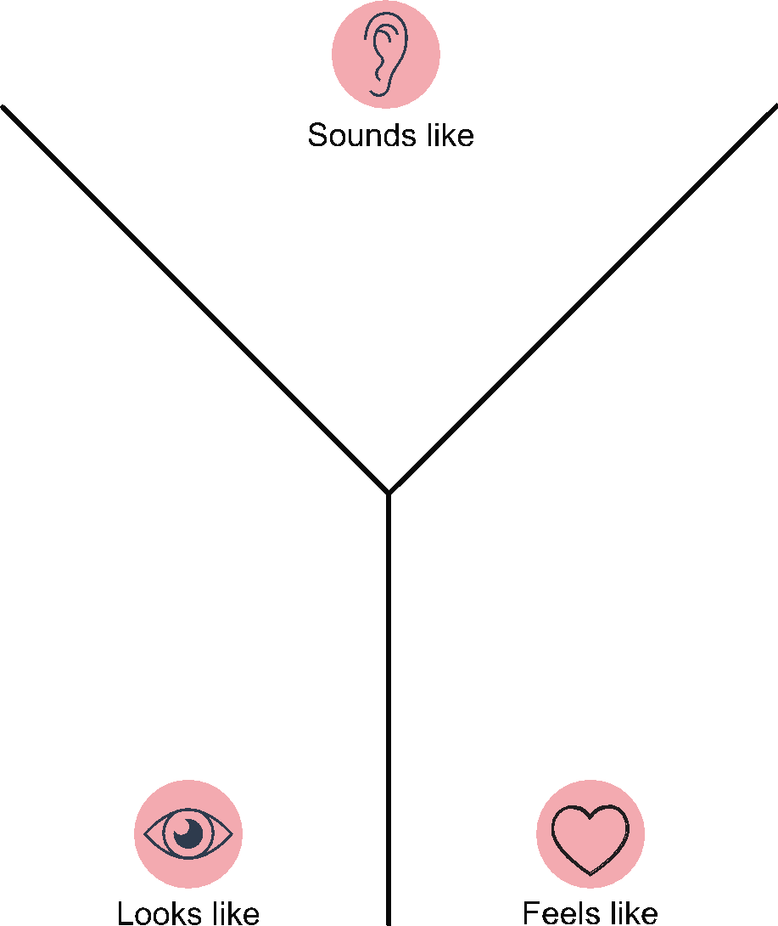

Worksheet: My support network of adults

Flower template

Hand template
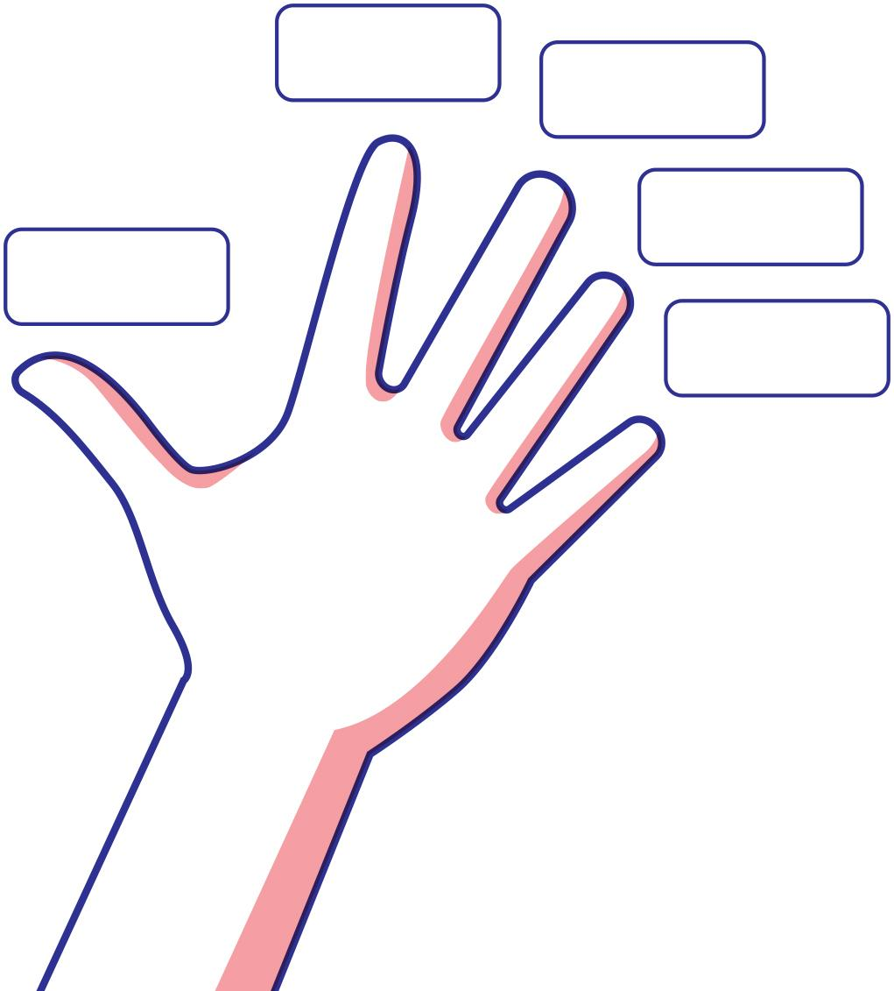

Cards: Body parts
arms | ear | neck
elbows | eyes | thighs
face | feet | nipples
fingers | hands | breasts
head | knee | anus
legs | lips | bottom
mouth | nose | testicles
shoulder | toes | penis
vulva | vagina

Worksheet: Body outlines
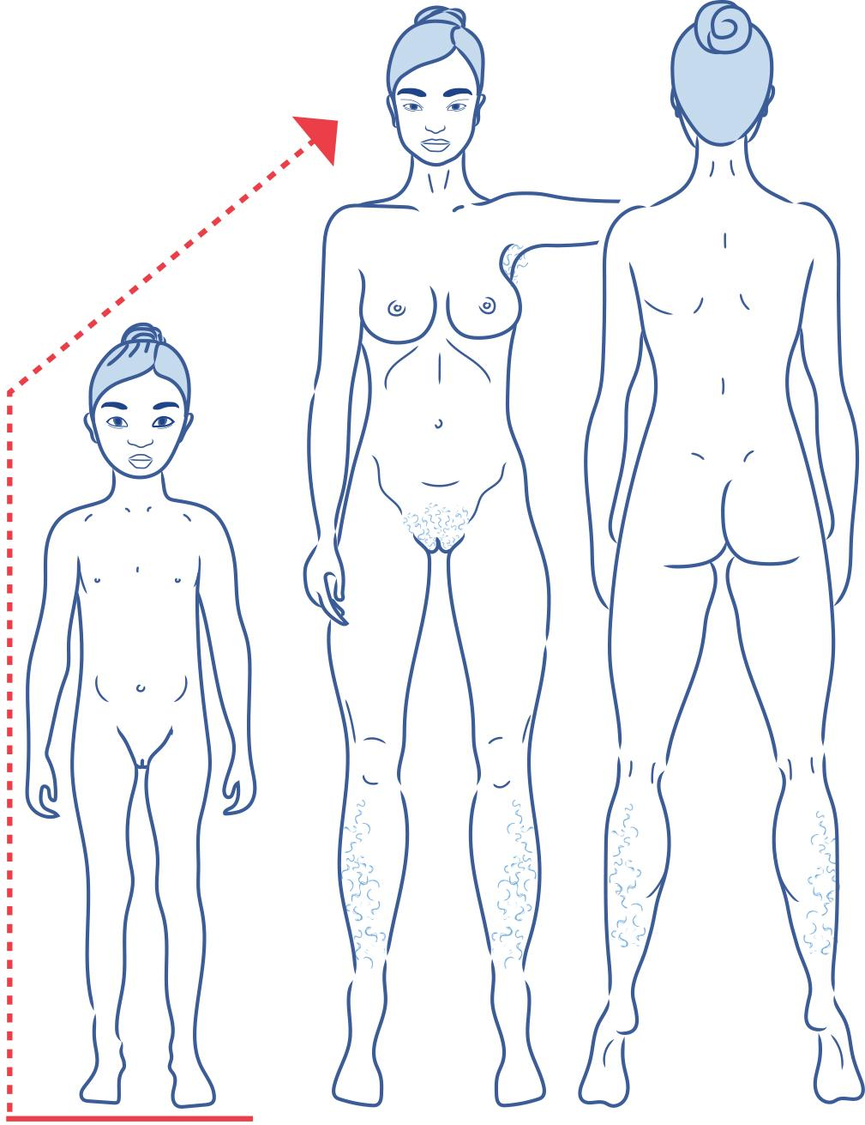
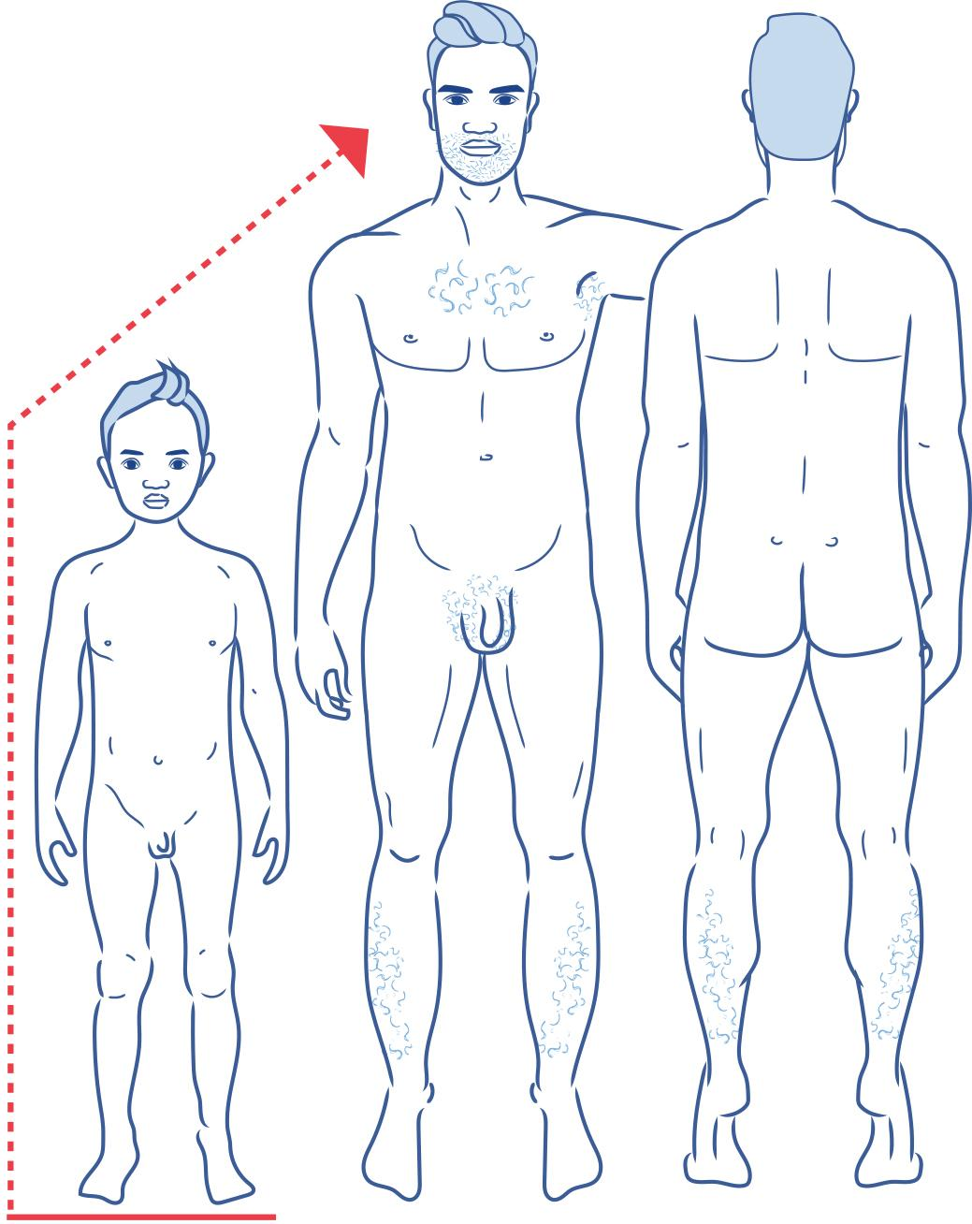

Body parts
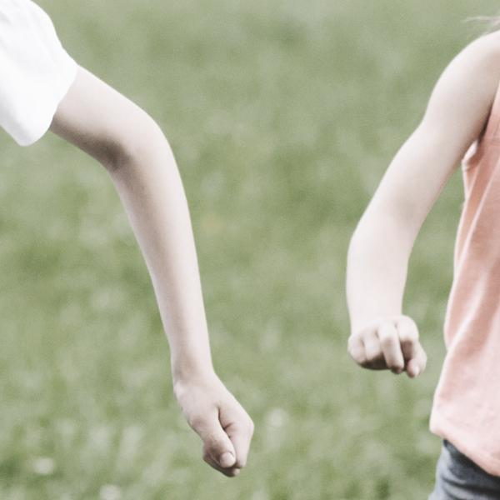 | 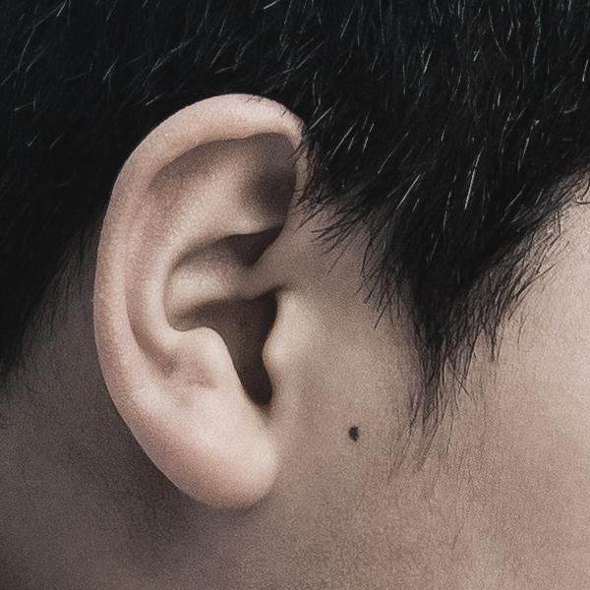 | 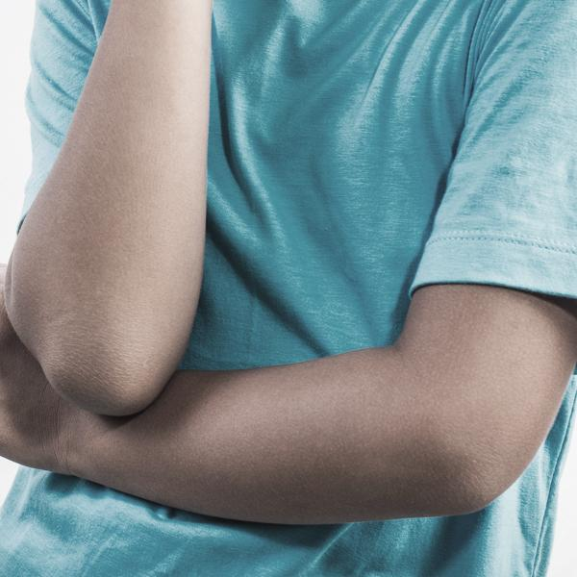
Arms | Ear | Elbows
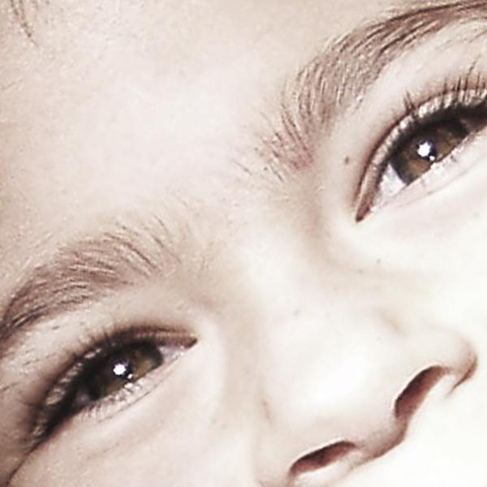 | 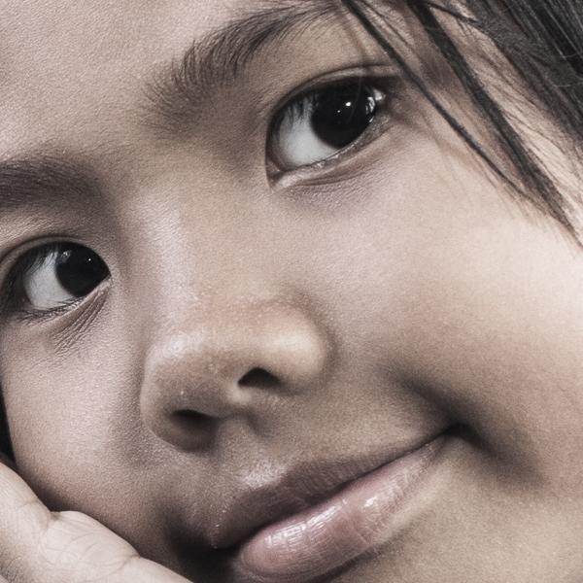 | 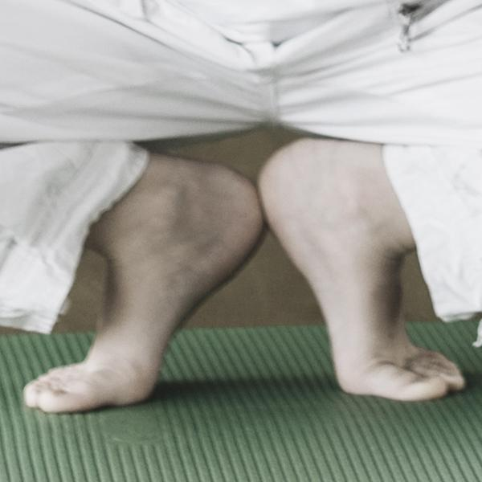
Eyes | Face | Feet
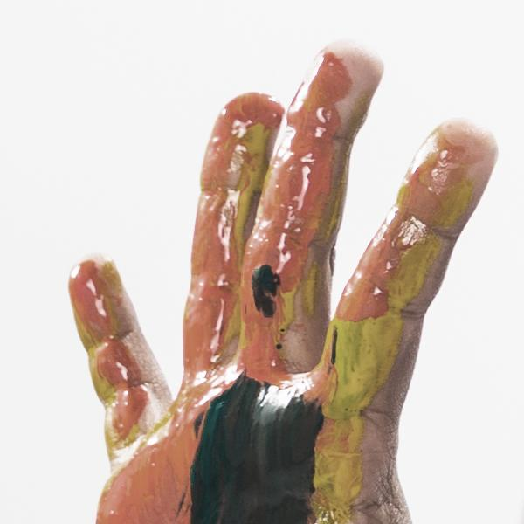 | 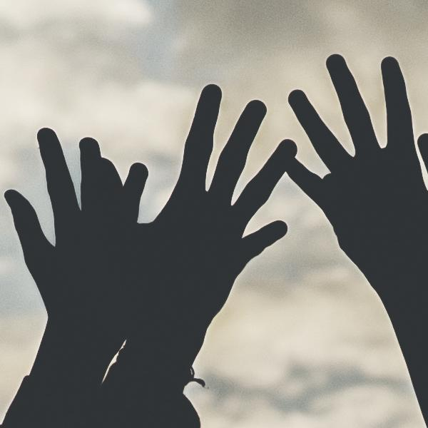 | 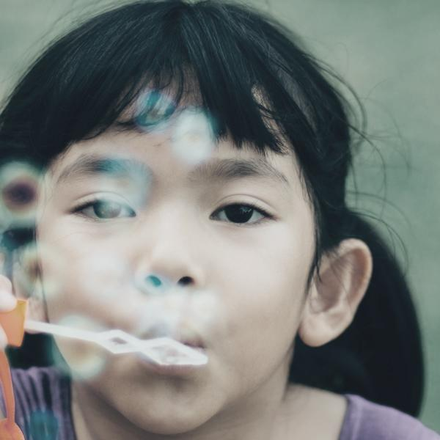
Fingers | Hands | Head
 |  | 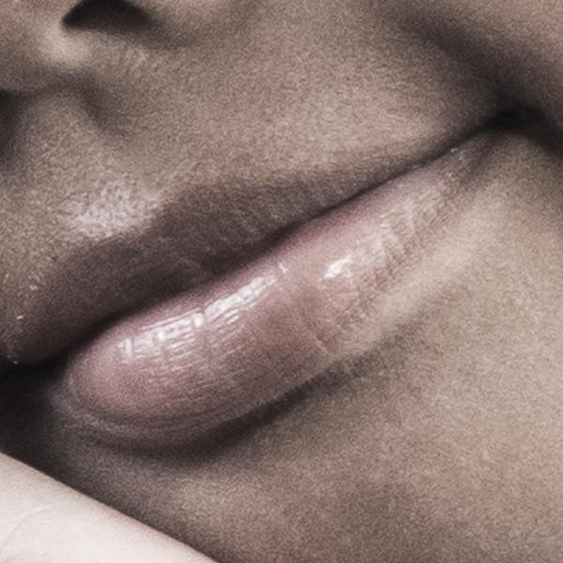
Knee | Legs | Lips
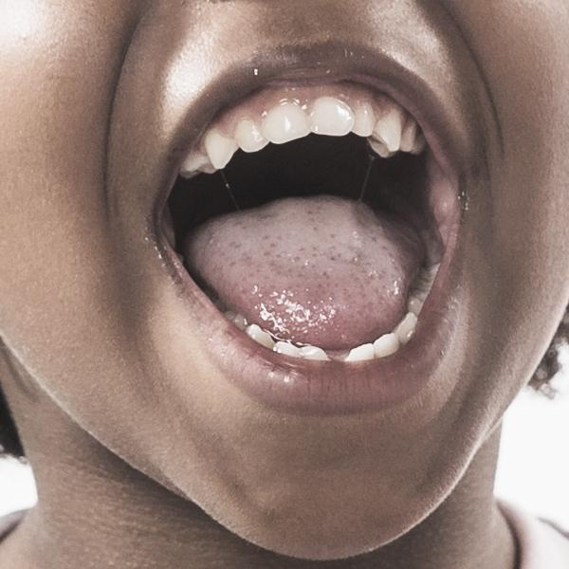 | 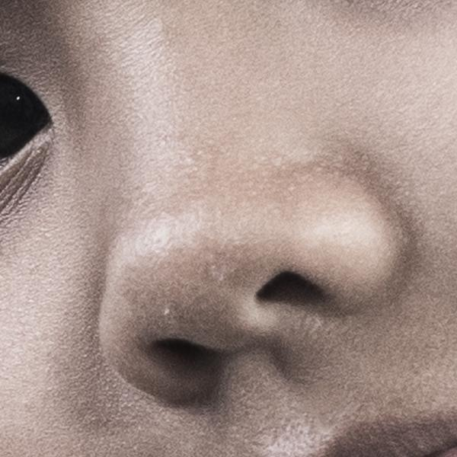 | 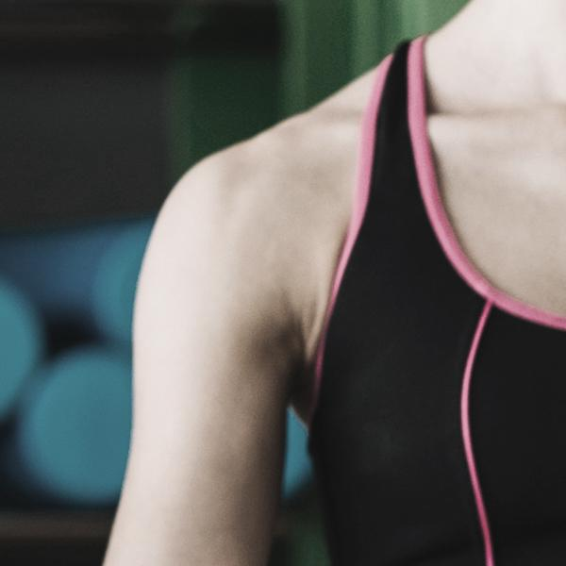
Mouth | Nose | Shoulder
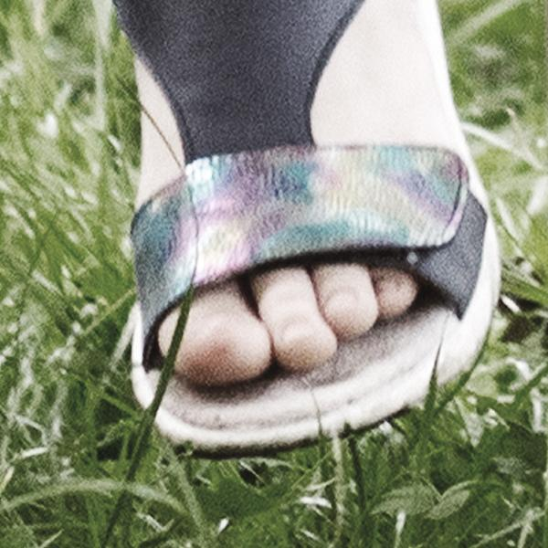
Toes
1

Worksheet: Feelings can change
Highlight the changing or mixed feelings the character may be feeling in each situation. Next to each situation record whether you think the character is safe or unsafe.

Ellen was at the park with her friends. They were playing a game of soccer. Ellen’s team was behind. In the last minute Ellen kicked a goal and her team won. It was time to go home. Ellen was feeling proud. She said goodbye to her friends. She walked across the park. A group of three older kids sitting around the swings whistled and made fun of her. | __ Safe  __ Unsafe
Himal was at home by himself. His Father would be home soon. Himal let himself into the house and phoned his Mother at work to let her know he was home safely. Himal’s Mother told him she had a special surprise for him tonight. Himal felt happy and started to do his homework. Someone knocked loudly on the front door. Himal looked outside and saw a neighbour. His parents had told him not to open the door to anyone. | __ Safe  __ Unsafe
Kegan went to stay at his friend’s house. They were having a great time playing until his friend had a fight with him and started teasing him. | __ Safe  __ Unsafe
Natasha’s Mother is in hospital as she had a baby. Natasha wonders if her Mother is ok and if she will like the baby. When Natasha’s Mother brings the new baby home, Natasha holds the baby and the baby seems to smile at her. Natasha likes the new baby but her Mother spends so much time with the baby that she doesn’t have time to play with Natasha anymore. Natasha starts to think that her Mother likes the baby more than her. | __ Safe  __ Unsafe
Roland is laughing loudly. His Uncle is tickling him. His Uncle keeps tickling him and starts to wrestle him. Roland starts to feel uncomfortable. He wants the tickling and wrestling to stop. He asks his Uncle to stop but his Uncle ignores him. | __ Safe  __ Unsafe
Tina is starting a new school. She meets the Principal and her new teacher and then she goes to her new class. She sits in her new seat. She sees that she is sitting next to a boy that she has met before. They smile at each other. At lunch time Tina asks if she can play with some girls from her class. One girl says she can’t and that she should go and play with her boyfriend. Some of the other girls laugh. | __ Safe  __ Unsafe

No-Go-Tell image
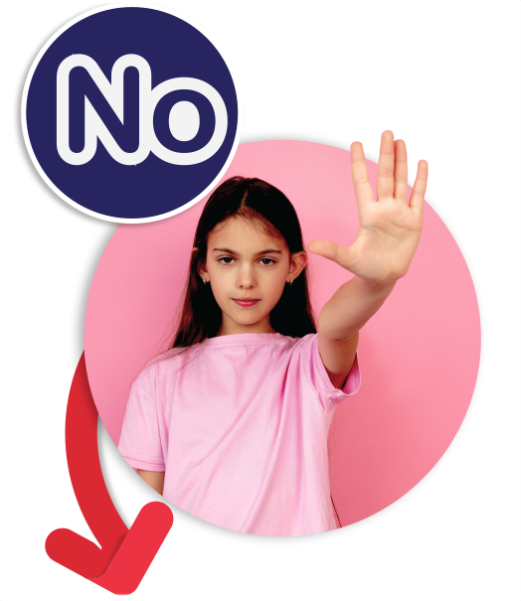2
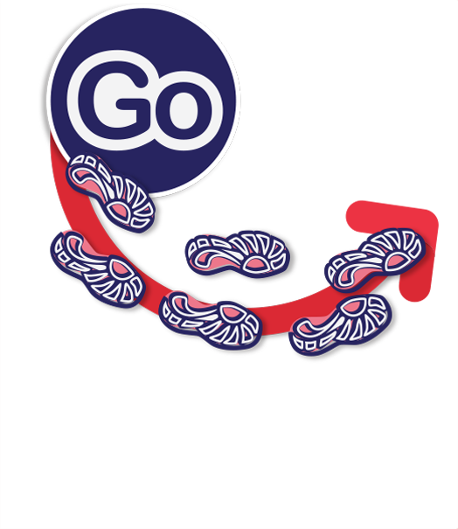3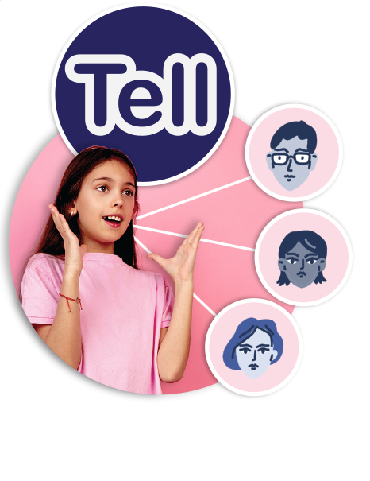4

Cards: Help-seeking situations
Essie gets into trouble all of the time at home. Sometimes she doesn’t even know what she’s done wrong but her Mum always hits her hard with an old broom handle. It hurts so much sometimes she can’t sit down properly. | Sandi was playing in his room and his older brother keeps throwing things in his room and constantly annoying him. He has asked him to stop but he won’t listen and Sandi is getting really annoyed.
Kane’s babysitter has been babysitting him since he was little. His babysitter always gives him special cuddles and touches his private parts. | Alex catches the bus home from school every day. In the afternoons some kids from another school share Alex’s bus. One of these kids keeps bumping into Alex, pushing Alex and throwing things at Alex from behind.
A neighbour in Mia’s street stares at her when they ride past her. They are older than Mia and when they are with their friends they point at Mia and laugh. | Dani’s friend has told her that someone in his family touches his private parts. He has asked Dani not to tell anyone.
Archer got into trouble at school for something he didn’t do. One of his friends let him get in trouble for something they did and now it’s Archer’s word against theirs. | Milla’s Aunty comes over to visit regularly. When she sees Milla she makes her kiss her and she squeezes Milla’s bottom.
Two of Suni’s friends at school have had an argument and won’t talk to each other. They both want Suni to be their friend and not be friends with the other person. Suni feels like she can’t play with either of them without the other one getting angry at her. | Patrick lives with his Grandparents and they fight a lot. One day Patrick’s Grandfather got so angry he hit Patrick’s Grandmother. Patrick’s Grandfather told him if he said anything he would hit him too.

Cards: Body signals
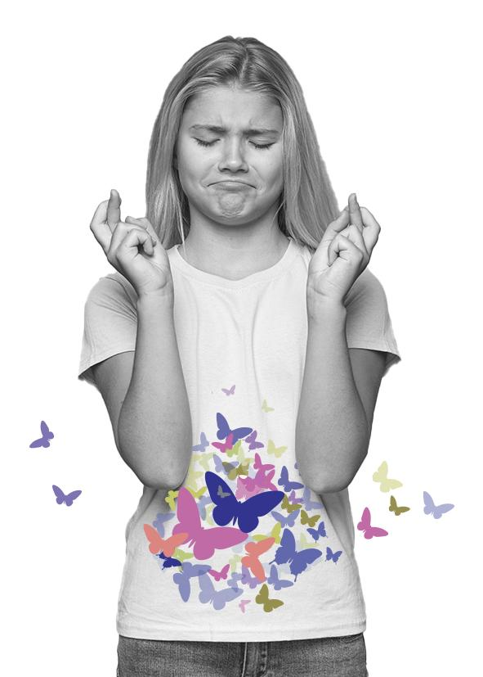5 | 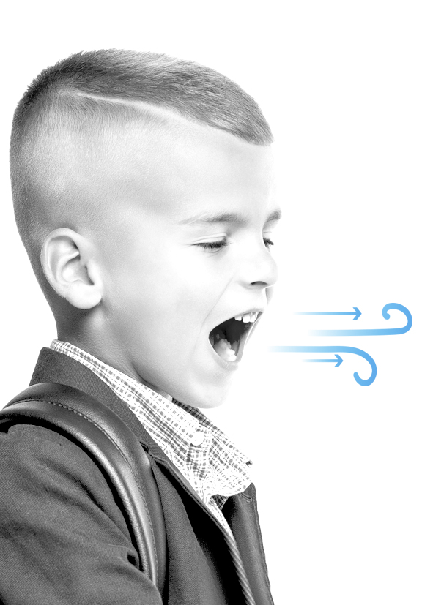6
Butterflies in your tummy | Quick breathing
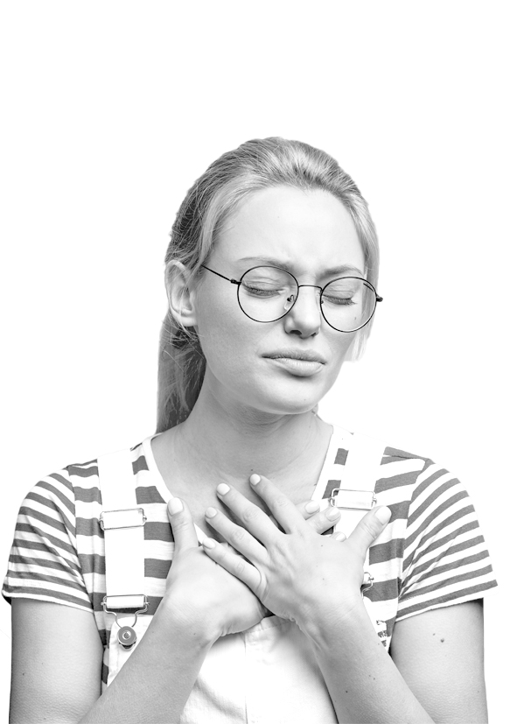7 | 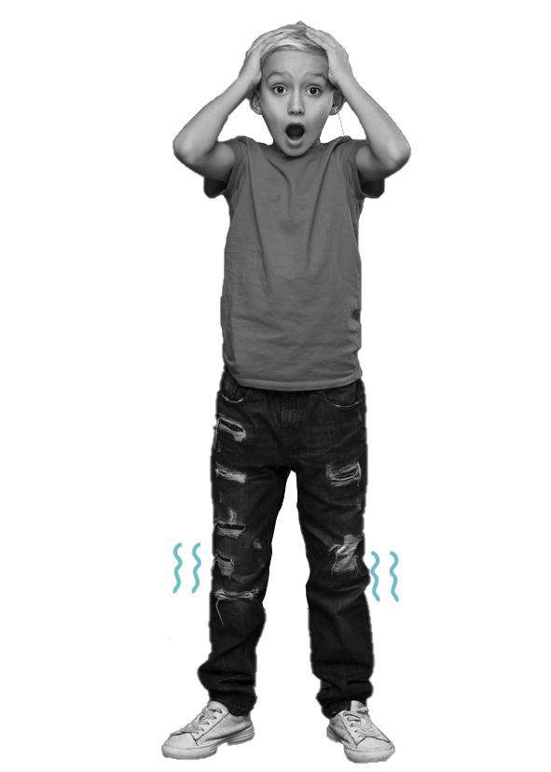8
Racing heart | Shaky knees
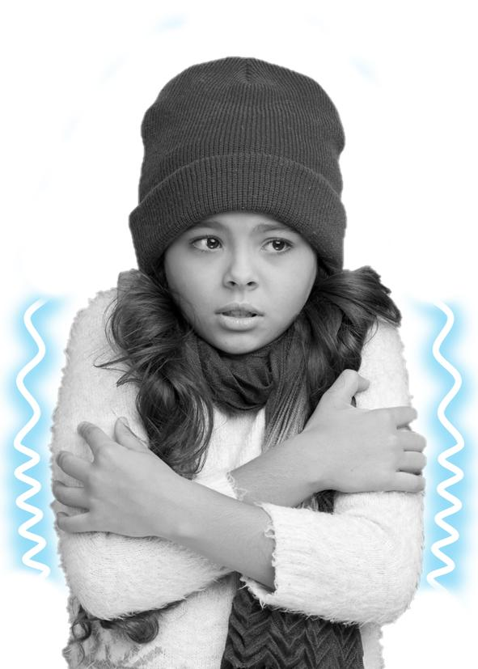 9 | 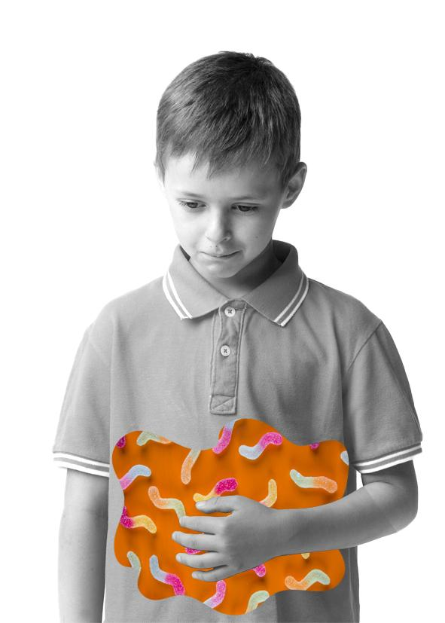10
Cold-shivery body | Squirmy tummy
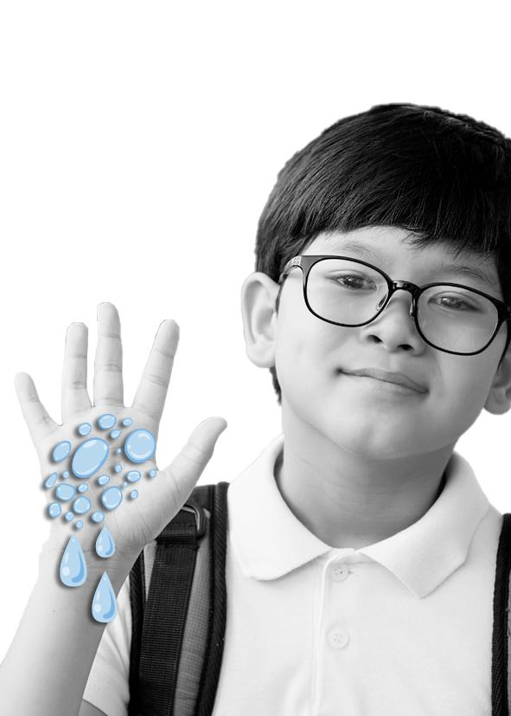11 | 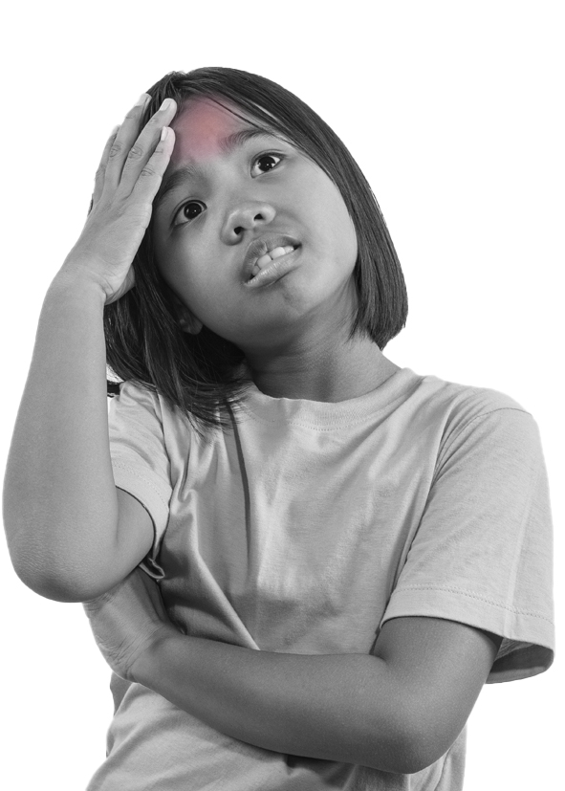12
Sweaty hands | Warm body

Cards: Secret scenarios
Read the scenarios and record your answer to the questions.

Dan was riding home from school when an older boy pushed his bike as he rode past. Dan fell off his bike. The older boy laughed and told Dan not to tell anyone or he would get him again.

Discussion questions:
- What body signals might you feel with this secret?
- Is this a happy secret or an unhappy secret?
- What might happen if you tell this secret?
- What might happen if you don’t tell this secret?
- What would you do?
Zara’s Mum was organising a special night out for Zara’s Dad for his birthday. Zara’s Mum asked her to keep it secret.

Discussion questions:
- What body signals might you feel with this secret?
- Is this a happy secret or an unhappy secret?
- What might happen if you tell this secret?
- What might happen if you don’t tell this secret?
- What would you do?
Samuel was playing a game online when someone asked if he could send them some photos of him. They said if Samuel sent a photo they would send him a new game for free.

Discussion questions:
- What body signals might you feel with this secret?
- Is this a happy secret or an unhappy secret?
- What might happen if you tell this secret?
- What might happen if you don’t tell this secret?
- What would you do?
Freya caught the bus to school every morning. An older kid from another school started to take her hat. When she told them to stop they took her bag as well. When Freya got off the bus the older kid told her if she said anything they wouldn’t give her stuff back next time.

Discussion questions:
- What body signals might you feel with this secret?
- Is this a happy secret or an unhappy secret?
- What might happen if you tell this secret?
- What might happen if you don’t tell this secret?
- What would you do?
Zen’s neighbour asked him to come inside because he’d bought him a new toy and wanted to give it to him. The neighbour said he couldn’t tell his parents that he had bought him a toy because they would be upset that he didn’t buy Zen’s sisters something as well.

Discussion questions:
- What body signals might you feel with this secret?
- Is this a happy secret or an unhappy secret?
- What might happen if you tell this secret?
- What might happen if you don’t tell this secret?
- What would you do?
Koa was at the shops with his parents and saw a friend from school. His friend was buying a birthday present for one of their classmates and asked Koa not to tell them what they had bought.

Discussion questions:
- What body signals might you feel with this secret?
- Is this a happy secret or an unhappy secret?
- What might happen if you tell this secret?
- What might happen if you don’t tell this secret?
- What would you do?
Emma’s dad is planning a surprise birthday party for her Mum. He told her not to tell her Mum.

Discussion questions:
- What body signals might you feel with this secret?
- Is this a happy secret or an unhappy secret?
- What might happen if you tell this secret?
- What might happen if you don’t tell this secret?
- What would you do?
Annie was playing with her friend Fran and noticed big bruises on her arm. Fran told Annie that her Dad gets angry sometimes and hurts her. She asked Annie not to tell anyone.

Discussion questions:
- What body signals might you feel with this secret?
- Is this a happy secret or an unhappy secret?
- What might happen if you tell this secret?
- What might happen if you don’t tell this secret?
- What would you do?

Worksheet: Secret to keep or secret to tell
Read each scenario and mark whether it is a secret that is ok to keep or if it is a secret that you should tell a trusted adult.

Dan was riding home from school when an older boy pushed his bike as he rode past. Dan fell off his bike. The older boy laughed and told Dan not to tell anyone or he would get him again. | __ Keep secret  __ Tell secret
Zara’s Mum was organising a special night out for Zara’s Dad for his birthday. Zara’s Mum asked her to keep it secret. | __ Keep secret  __ Tell secret
Samuel was playing a game online when someone asked if he could send them some photos of him. They said if Samuel sent a photo they would send him a new game for free. | __ Keep secret  __ Tell secret
Freya caught the bus to school every morning. An older kid from another school started to take her hat. When she told them to stop they took her bag as well. When Freya got off the bus the older kid told her if she said anything they wouldn’t give her stuff back next time. | __ Keep secret  __ Tell secret
Zen’s neighbour asked him to come inside because he’d bought him a new toy and wanted to give it to him. The neighbour said he couldn’t tell his parents that he had bought him a toy because they would be upset that he didn’t buy Zen’s sisters something as well. | __ Keep secret  __ Tell secret
Koa was at the shops with his parents and saw a friend from school. His friend was buying a birthday present for one of their classmates and asked Koa not to tell them what they had bought. | __ Keep secret  __ Tell secret
Emma’s Dad is planning a surprise party for her Mum. He told her not to tell her Mum. | __ Keep secret  __ Tell secret
Annie was playing with her friend Fran and noticed big bruises on her arm. Fran told Annie that her Dad gets angry sometimes and hurts her. She asked Annie not to tell anyone. | __ Keep secret  __ Tell secret

Copyright register
- Body parts: Kids photo created by freepik – www.freepik.com
- No girl: People photo created by master1305 – www.freepik.com
- Go footprints: Background vector created by macrovector_official – www.freepik.com
- Tell girl: People photo created by master1305 – www.freepik.com
Trusted people headshots: People vector created by freepik – www.freepik.com
- Butterflies in your tummy butterflies: Background photo created by freepik – www.freepik.com
butterflies in your tummy girl: Woman vector created by freepik – www.freepik.com
- Quick breathing boy: Food photo created by diana.grytsku – www.freepik.com
- Racing heart girl: People photo created by wayhomestudio – www.freepik.com
- Shaky knees: Shaky knees boy: Cute photo created by drobotdean – www.freepik.com
- Cold shivery body girl: Winter photo created by freepik – www.freepik.com
- Squirmy tummy boy: Background photo created by freepik – www.freepik.com
Worms: Food photo created by freepik – www.freepik.com
- Sweaty hands boy: School photo created by jcomp – www.freepik.com
Droplets: Water vector created by pch.vector – www.freepik.com
- Warm body girl: Designed by jcomp – www.freepik.com

