SCHOOL HOLIDAY ROAD SAFETY REMINDER
FOR FAMILIES

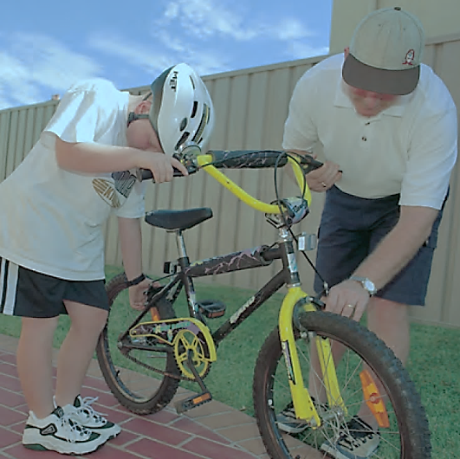
With the school holidays approaching, daily routines will soon change. Different play locations and holiday destinations means different traffic environments.
So to help keep our children safe, families are reminded about these key road safety points:
- Stop, look, listen, think every time you cross the road.
If your child is aged 8 years or younger hold their hand when walking near or across roads. If your child is 9-10 years old always actively supervise them.

- It’s the law that everyone wears a helmet when riding a bike in a public place.
It makes sense to wear a helmet when riding scooters and skateboards too!

- Click clack front ‘n back every person for every trip.
Everyone in the car must be securely buckled up in the right seatbelt or child restraint.

- Talk to your child about being a safe road user.
Reinforce safe road behaviours by being a good role model! Children learn safe road behaviours from the adults who care for them. Talk about what you are doing to be safe when near roads, in the car and when riding.

- Point out road safety differences and dangers in new environments.
This is especially important when on holidays in different surroundings. Roads, footpaths, parks, carparks, bike tracks and bike lanes may look different in holiday areas.
The best way to keep your child safe is to actively supervise them.
Talk and teach your child about road safety every time you are out an about.
Remind other adults who care for your children to do this too.
You can find out more at:
Safe travel information for parents and carers NSW Department of Education
Back to school safety Transport for NSW
Safety Town online resource – parent and carer information – Transport for NSW

Have a safe holiday break!

