 | Morning session  The Seasons and Weather – A simple learning from home plan | Middle session | Middle session | Afternoon session
1  Weather | KLA – English  - Read “Maisy’s wonderful weather book” Lucy Cousins  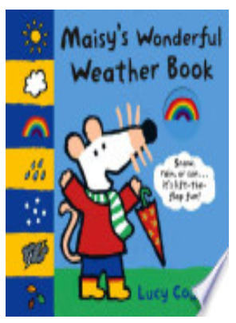  - Skills – Choose a Super Six comprehension strategy  https://coffsharb-h.schools.nsw.gov.au/content/dam/doe/sws/schools/c/coffsharb-h/localcontent/super_six_parenthandout.pdf | KLA – Creative Arts – Visual Arts  - Weather chart  - Skills - water painting, paintbrush use, choice making, tactile art | KLA – H.S.I.E  - What do we wear in different weather  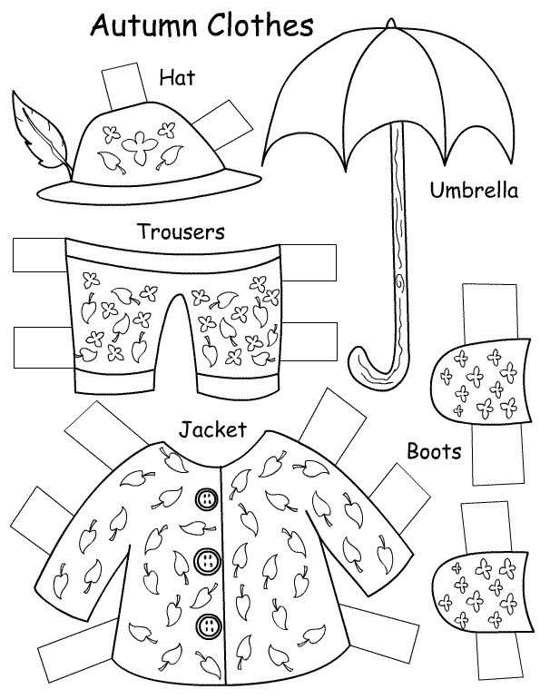  - Skills – dress ups, choice making, painting. | KLA – Mathematics  - Graph the weather every day for a month  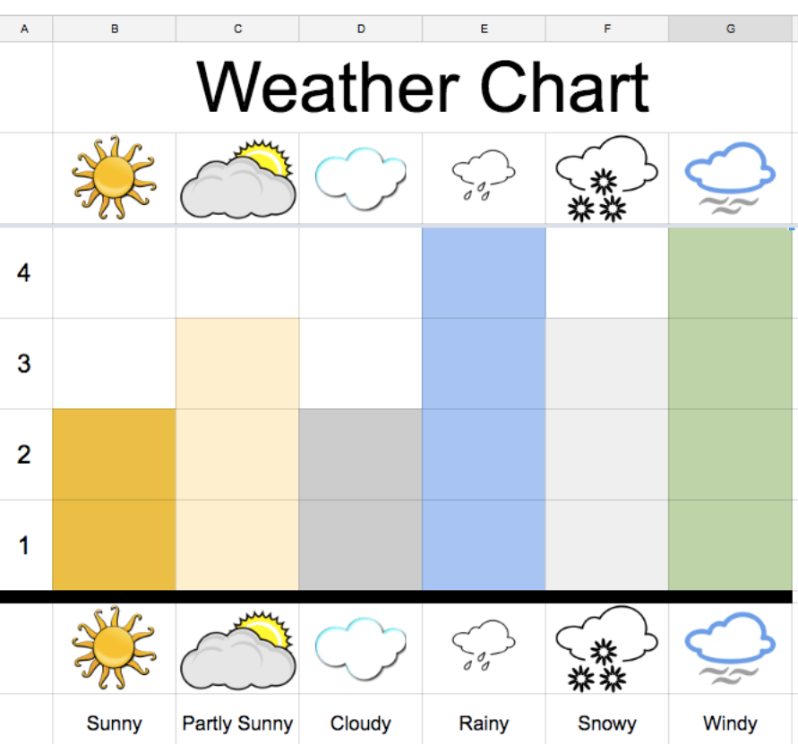  - Skills – counting (Jack Hartman counting songs)
2  Sun | KLA – English  - Read “What is the weather today”  https://www.youtube.com/watch?v=BgvbpxTX0rM  - Skills – Super six comprehension strategies | KLA – Creative Arts – Visual Arts  - Handprint Sun  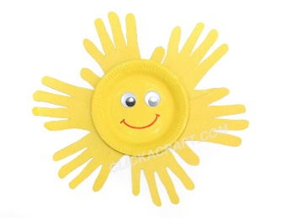  - Skills – painting, brush use, cutting, pasting. | KLA – Creative Arts – Visual Arts  - Beach Scene - background  - Skills – painting, brush use, cutting, pasting. | KLA – PD/H/PE  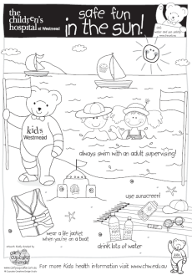  - Talk about why we wear a hat at school. Sing the slip slop slap song  - Worksheet  - Skills – colouring, choice making
3  Clouds | KLA – English  - Read “The cloud book” Tomie de Paola  https://www.youtube.com/watch?v=eS5uN0RuIHI  - Skills – Super six comprehension strategy | KLA – Creative Arts – Visual Arts  - Puffy Clouds  - Skills – Choice making, paintbrush use, Sensory art  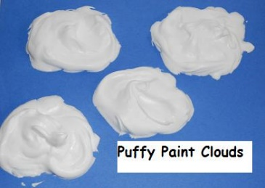 | 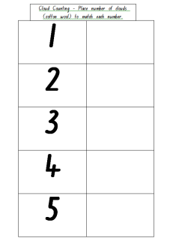  KLA – Maths  - Cloud Counting  - Skills – Counting 1 -5 or beyond  - Number before/ after | KLA – Science and technology  - Cooking. Blue Jelly and ice-cream Sundays.  - Skills – stirring, mixing, and using a spoon.
4  Rain | KLA – English  - Read “The Storm” by Charlotte Zolotow  and “Rain in the city”  http://d20uo2axdbh83k.cloudfront.net/20141006/8d1906cde36563245d9c8cd9548fdf52/B_Rain_In_The_City.pdf  - Super six comprehension strategy | KLA – Creative Arts – Visual Arts  - Umbrella and Rain  - Skills – Choice making, paintbrush use, Sensory art  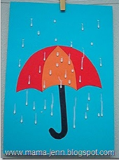 | KLA – Science  - Make a rainmaker using beads, rice and lentils.  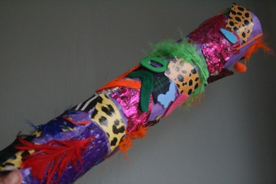  - Skills – Painting, craft, fine motor. Choice making | KLA – Music  - It’s raining it’s pouring,  Come under my umbrella  Put my raincoat on  - Skills – gross motor, listening to music, rhythm.
5  Rainbow | KLA – English  - Sing “I can sing a rainbow”  https://www.bing.com/videos/search?q=i+can+sing+a+rainbow+sign+language&docid=608004679640812181&mid=BC57B48FB64B872B00E6BC57B48FB64B872B00E6&view=detail&FORM=VIRE  - Skills – Super six comprehension strategies | KLA – Creative Arts – Visual Arts  - Tactile rainbow  - Skills – Choice making, paintbrush use, Sensory art  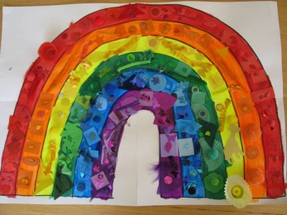 | KLA – Maths –  - Colour Matching  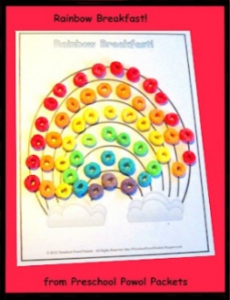  - Skills – colour matching, fine motor skills. | KLA – Science and technology  - Cooking. Rainbow cupcakes  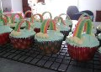  Skills – stirring, mixing, and using a spoon.
6  Wind | KLA – English  - Read “Go fly a Kite”  https://www.readinga-z.com/books/leveled-books/book/?id=2721&langId=1  - Skills – Super six comprehension strategies | KLA – Creative Arts – Visual Arts  - Make a Kite with a paper bag  - Skills – Choice making, paintbrush use, Sensory art  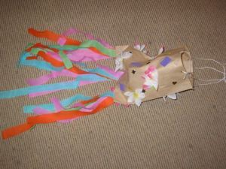 | KLA – Science  - Experiment – what can be blown by wind  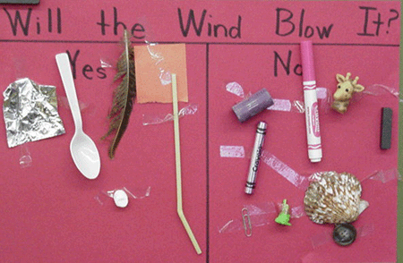  - Skills – choice making, predicting. Indicating yes/no | KLA – Science  - Make a pinwheel, test it outside on a windy day  - Skills – Painting, craft, fine motor. Choice making  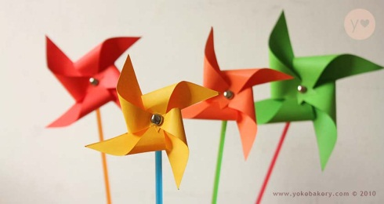
7  Snow | KLA – English  - Read “How to make a snow person” https://www.bing.com/videos/search?q=how+to+make+a+snow+person&docid=608017190877531244&mid=74C4B9AA236D86EE32D174C4B9AA236D86EE32D1&view=detail&FORM=VIRE  - Brain Break, Penguin dance, Jack Hartman  https://www.youtube.com/watch?v=uf0uKmKwnKs  - Skills – Super six comprehension strategies | KLA – Creative Arts – Visual Arts  - Make a snow man using shredded paper.  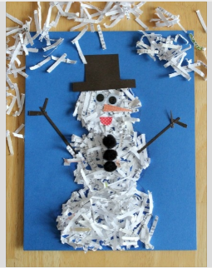  - Skills – Choice making, paintbrush use, Sensory art | KLA – English  - Snow men names  - Skills – Spelling name, matching sounds. | KLA – English  - Star fall – Snowman  - www.starfall.com
8  Summer | KLA – English  - Watch “Grandpa and Thomas’ https://www.youtube.com/watch?v=37MlnaEA_Ic  - Skills – Super six comprehension strategies | KLA – Creative Arts – Visual Arts  - Using Bubble wrap make a tree for all the different seasons  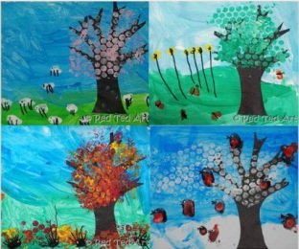  - Skills – Choice making, paintbrush use, Sensory art | KLA – English  - “In summer we” worksheet. Find pictures of people in magazines
9  Autumn | KLA – English  - Watch “A book of seasons” https://www.youtube.com/watch?v=WhDJDIviAOg  - Brain Break: Song Four seasons in the southern hemisphere, Jack Hartman  https://www.youtube.com/watch?v=061ePX3k-hA  - Skills- Super six comprehension strategies | KLA – Creative Arts – Visual Arts  - Use pretzels and crepe paper to make an autumn tree.  - Skills – Choice making, gluing, Sensory art  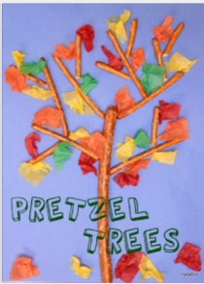 | KLA – H.S.I.E  - Find Autumn leaves in the garden. Discuss how they feel, look, smell. | KLA – English  - Colour in or use tactile materials to decorate the leaf.  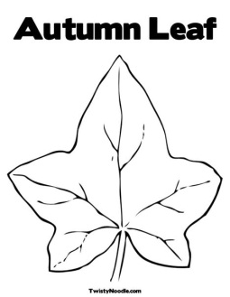  Skills – colouring, fine motor skills.
10  Winter | KLA – English  - Read “Snow Day” https://www.youtube.com/watch?v=ievFNlEUnLI  - Skills – super six comprehension strategies | KLA – Creative Arts – Visual Arts  - Use paper doily’s to make snowflake design  - Skills – painting, choice making.  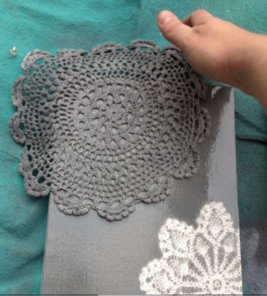 | KLA – English  - Snow man faces. Students take photos of themselves. Colour in snowman picture.  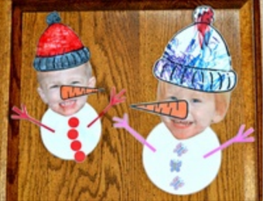  - Skills – Choice Making, cutting pasting | KLA – English  - “In winter we” worksheet- Find pictures of people in magazines  - Skills – Choice Making, cutting pasting
11  Spring | KLA – English  - Watch Welcome to Spring https://www.bing.com/videos/search?q=spring+time+for+kids&ru=%2fvideos%2fsearch%3fq%3dspring%2520time%2520for%2520kids%26qs%3dMM%26form%3dQBVR%26sp%3d7%26pq%3dspring%2520tiime%2520%26sk%3dMM6%26sc%3d8-13%26cvid%3d4DCC43BB528E47398B40BF9895AA6354&view=detail&mid=2570CFA3A06B66EEDA8E2570CFA3A06B66EEDA8E&&FORM=VDRVRV  - Brain Break: Spring Time Dance Song, Jack Hartman  https://www.bing.com/videos/search?q=spring+time+for+kids&ru=%2fvideos%2fsearch%3fq%3dspring%2520time%2520for%2520kids%26qs%3dMM%26form%3dQBVR%26sp%3d7%26pq%3dspring%2520tiime%2520%26sk%3dMM6%26sc%3d8-13%26cvid%3d4DCC43BB528E47398B40BF9895AA6354&view=detail&mid=2570CFA3A06B66EEDA8E2570CFA3A06B66EEDA8E&&FORM=VDRVRV  - Skills – super six comprehension strategies | 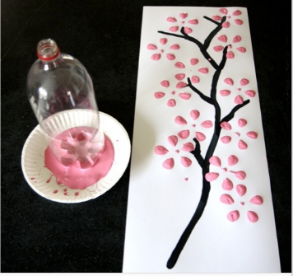 KLA – Creative Arts – Visual Arts  - Use a soft drink bottle to make flowers on a tree.  - Skills – painting, choice making. | KLA – English  - “Spring” matching worksheet.  - Skills – cutting, phonics, letter recognition. | KLA – Science and technology  - Cooking – Make popcorn  - Decorate a tree using popcorn to imitate flowers.  